**Name: Tong Wu CWID: A20410395**

Table of Contents

PART 1: 2-172

PART 2: 172-181

**PART1 is my key code and PART2 is my application’s screenshots.**

**PART1:**

**Code:**

**Only show Java code and jsp code in this file, css and js code will upload in github**

**I use navicat for MySQL as my database because my local MySQL Workbench can not execute function which I wrote in finalproject.sql file.**

Dao.AdminDao

package Dao;

import java.sql.Connection;

import java.sql.PreparedStatement;

import java.sql.ResultSet;

import java.sql.SQLException;

import Model.Admin;

public class AdminDao {

public Admin selectAdmin(String inputemail) {

Connection connection = null;

PreparedStatement psmt = null;

Admin a= new Admin();

try {

connection = DBDao.getConnection();

String sql ="select * from admin where email="+"'"+inputemail+"'";

psmt = (PreparedStatement) connection.prepareStatement(sql);

ResultSet rs = psmt.executeQuery();

while(rs.next()){

a.setEmail(rs.getString(1));

a.setPassword(rs.getString(2));

}

} catch (SQLException e) {

// TODO Auto-generated catch block

e.printStackTrace();

}finally {

DBDao.closeConnection(connection);

} return a;

}

}

Dao.DBDao

package Dao;

import java.sql.Connection;

import java.sql.DriverManager;

import java.sql.SQLException;

public class DBDao {

static String sqlStr = "jdbc:mysql://localhost/CarService?characterEncoding=UTF-8";

static String rootName = "root";

static String rootPwd = ""; //Tongky100%

static Connection connection;

public static Connection getConnection(){

try {

Class.forName("com.mysql.jdbc.Driver");

connection = DriverManager.getConnection(sqlStr,rootName,rootPwd);

} catch (Exception e) {

System.out.println("connection error");

e.printStackTrace();

}

return connection;

}

public static void closeConnection(Connection connection){

if(connection != null){

try {

connection.close();

} catch (SQLException e) {

e.printStackTrace();

}

}

}

}

Dao.UserDao

package Dao;

import java.sql.Connection;

import java.sql.PreparedStatement;

import java.sql.ResultSet;

import java.sql.SQLException;

import Model.User;

public class UserDao {

public void addUser(User user) {

Connection connection = null;

PreparedStatement psmt = null;

try {

connection = DBDao.getConnection();

String sql ="insert into user(UserName,PassWord,Email,State,City,StreetAddress,Role)values(?,?,?,?,?,?,?);";

psmt = (PreparedStatement) connection.prepareStatement(sql);

psmt.setString(1,user.getUsername());

psmt.setString(2,user.getPassword());

psmt.setString(3,user.getEmail());

psmt.setString(4,user.getState());

psmt.setString(5,user.getCity());

psmt.setString(6,user.getStreetaddress());

psmt.setString(7,"customer");

psmt.executeUpdate();

} catch (SQLException e) {

// TODO Auto-generated catch block

e.printStackTrace();

}finally {

DBDao.closeConnection(connection);

}

}

public User selectUser(String inputemail) {

Connection connection = null;

PreparedStatement psmt = null;

User u = new User();

try {

connection = DBDao.getConnection();

String sql ="select * from user where email="+"'"+inputemail+"'";

psmt = (PreparedStatement) connection.prepareStatement(sql);

ResultSet rs = psmt.executeQuery();

while(rs.next()){

u.setUsername(rs.getString(1));

u.setPassword(rs.getString(2));

u.setEmail(rs.getString(3));

u.setState(rs.getString(4));

u.setCity(rs.getString(5));

u.setStreetaddress(rs.getString(6));

u.setRole(rs.getString(7));

}

} catch (SQLException e) {

// TODO Auto-generated catch block

e.printStackTrace();

}finally {

DBDao.closeConnection(connection);

} return u;

}

}

org.great.ctrl.BusinessDao

package org.great.ctrl;

import java.util.List;

import java.util.Map;

import org.great.entity.Buy;

import org.great.entity.Car;

import org.great.entity.CarPart;

import org.great.entity.CustomerAccount;

import org.great.entity.Files;

import org.great.entity.Power;

import org.great.entity.User;

public interface BusinessDao {

//Login

Map<String, String> login(String userName,String password);

//access permission

Power select_power(String rightid);

//get user list

List<User> getUserList();

//get user list

List<User> getUserLists(String email);

//add user

boolean addUser(User user);

//delete user

void delUser(String email);

//delete users' access permission

boolean delRights(String username);

//get user account list

List<User> getUserList2();

//modify user account

boolean updateUser2(User user);

//modify user account

boolean updateUser3(User user);

//get user information

User getUser(String email,String username);

//get user information

User getUser(String email);

//get user account balance

String getUserAccount(String email);

//add user access

boolean addRights(String username);

//check customer account

CustomerAccount getCustomerAccount(String email);

//update cutomer account

boolean updateCustomerAccount(User user);

//get car list

List<Car> getCarList();

//add new car

boolean addCar(Car car);

//delete car

boolean delCar(String id);

//get carpart list

List<CarPart> getCarPartList();

//add new carpart

boolean addCarPart(CarPart carpart);

//delete carpart

boolean delCarPart(String id);

//get buying count

String getBuyCount(String email,String name);

//get buying number

String getBuyNum(String email);

//add buying record

boolean addBuyRecord(Buy buy);

//get buying list

List<Buy> getBuyList();

//add new car

boolean addFiles(Files files);

}

org.great.ctrl.BusinessDaoFactory

**package** org.great.ctrl;

**public** **class** BusinessDaoFactory {

**private** **static** BusinessDao *businessDao* = **null**;

**private** **static** BusinessDaoFactory *instance* = **null**;

**private** BusinessDaoFactory() {

**try** {

Class<?>clazz = Class.*forName*("org.great.ctrl.BusinessDaoImpl");

*businessDao* = (BusinessDao) clazz.newInstance();

} **catch** (Exception e) {

e.printStackTrace();

}

}

**public** **static** BusinessDaoFactory getInstance()

{

**if**(*instance* == **null**)

{

*instance* = **new** BusinessDaoFactory();

}

**return** *instance*;

}

**public** BusinessDao getBusinessDao()

{

**return** *businessDao*;

}

}

org.great.ctrl.BusinessDaoImpl

package org.great.ctrl;

import java.sql.Connection;

import java.sql.PreparedStatement;

import java.sql.ResultSet;

import java.sql.SQLException;

import java.util.ArrayList;

import java.util.HashMap;

import java.util.List;

import java.util.Map;

import org.great.entity.Buy;

import org.great.entity.Car;

import org.great.entity.CarPart;

import org.great.entity.CustomerAccount;

import org.great.entity.Files;

import org.great.entity.Power;

import org.great.entity.User;

import org.great.util.Util;

public class BusinessDaoImpl implements BusinessDao {

public BusinessDaoImpl() {

}

@Override

public CustomerAccount getCustomerAccount(String email) {

return null;

}

@Override

public boolean updateCustomerAccount(User user) {

return false;

}

@Override

public List<Car> getCarList() {

Connection conn = Util.getInstance().getConnetionMirror();

PreparedStatement statement = null;

ResultSet result = null;

List<Car> list =new ArrayList<Car>();

try {

statement=conn.prepareStatement("select * from car");

result=statement.executeQuery();

while(result.next()){

Car car =new Car();

car.setId(result.getString("id"));

car.setName(result.getString("name"));

car.setType(result.getString("type"));

car.setBuyPrice(result.getDouble("buyPrice"));

car.setRentPrice(result.getDouble("rentPrice"));

car.setFilecode(result.getString("filecode"));

car.setFilepath(result.getString("filepath"));

car.setImgpath(result.getString("imgpath"));

list.add(car);

}

} catch (SQLException e) {

e.printStackTrace();

}finally{

try {

if(conn!=null){

conn.close();

}

if(statement!=null){

statement.close();

}

if(result!=null){

result.close();

}

} catch (SQLException e) {

e.printStackTrace();

}

}

return list;

}

@Override

public boolean addCar(Car car) {

String sql="insert into car values(nextval('seq_car'),?,?,?,?,?,?,?)";

Object[] params={car.getName(),car.getType(),car.getBuyPrice(),car.getRentPrice(),car.getFilecode(),car.getFilepath(),car.getImgpath()};

update(sql, params);

return true;

}

@Override

public boolean delCar(String id) {

Connection conn = Util.getInstance().getConnetionMirror();

PreparedStatement statement = null;

ResultSet result = null;

try {

statement=conn.prepareStatement("delete from car where id =?");

statement.setString(1, id);

statement.execute();

return true;

} catch (SQLException e) {

e.printStackTrace();

}finally{

try {

if(conn!=null){

conn.close();

}

if(statement!=null){

statement.close();

}

if(result!=null){

result.close();

}

} catch (SQLException e) {

e.printStackTrace();

}

}

return false;

}

@Override

public List<CarPart> getCarPartList() {

Connection conn = Util.getInstance().getConnetionMirror();

PreparedStatement statement = null;

ResultSet result = null;

List<CarPart> list =new ArrayList<CarPart>();

try {

statement=conn.prepareStatement("select * from carpart");

result=statement.executeQuery();

while(result.next()){

CarPart carpart =new CarPart();

carpart.setId(result.getString("id"));

carpart.setName(result.getString("name"));

carpart.setBuyprice(result.getDouble("buyprice"));

carpart.setFilecode(result.getString("filecode"));

carpart.setFilepath(result.getString("filepath"));

carpart.setImgpath(result.getString("imgpath"));

list.add(carpart);

}

} catch (SQLException e) {

e.printStackTrace();

}finally{

try {

if(conn!=null){

conn.close();

}

if(statement!=null){

statement.close();

}

if(result!=null){

result.close();

}

} catch (SQLException e) {

e.printStackTrace();

}

}

return list;

}

@Override

public boolean addCarPart(CarPart carpart) {

String sql="insert into carpart values(nextval('seq_carpart'),?,?,?,?,?)";

Object[] params={carpart.getName(),carpart.getBuyprice(),carpart.getFilecode(),carpart.getFilepath(),carpart.getImgpath()};

update(sql, params);

return true;

}

@Override

public boolean delCarPart(String id) {

Connection conn = Util.getInstance().getConnetionMirror();

PreparedStatement statement = null;

ResultSet result = null;

try {

statement=conn.prepareStatement("delete from carpart where id =?");

statement.setString(1, id);

statement.execute();

return true;

} catch (SQLException e) {

e.printStackTrace();

}finally{

try {

if(conn!=null){

conn.close();

}

if(statement!=null){

statement.close();

}

if(result!=null){

result.close();

}

} catch (SQLException e) {

e.printStackTrace();

}

}

return false;

}

@Override

public String getBuyNum(String email) {

// TODO Auto-generated method stub

Connection conn = Util.getInstance().getConnetionMirror();

PreparedStatement statement = null;

ResultSet result = null;

String buynum = "0";

try {

statement=conn.prepareStatement("select buynum from buy where buyuseremail =?");

statement.setString(1, email);

result=statement.executeQuery();

if(result.next()){

buynum = result.getString("buynum");

}

} catch (SQLException e) {

e.printStackTrace();

}finally{

try {

if(conn!=null){

conn.close();

}

if(statement!=null){

statement.close();

}

if(result!=null){

result.close();

}

} catch (SQLException e) {

e.printStackTrace();

}

}

return buynum;

}

@Override

public boolean addBuyRecord(Buy buy) {

String sql="insert into buy values(nextval('seq_buy'),?,?,?,?,?,?)";

//String sql="insert into buy values(?,?,?,?,?,?)";

Object[] params={buy.getName(),buy.getBuynum(),buy.getBuytime(),buy.getBuyuser(),buy.getBuyuseremail(),buy.getBuytype()};

update(sql, params);

return true;

}

@Override

public Map<String, String> login(String userName, String password) {

Connection conn = Util.getInstance().getConnetionMirror();

PreparedStatement statement = null;

ResultSet result = null;

Map<String, String> map = new HashMap<String,String>();

map.put("isLogin", "flase");

map.put("role", "-1");

try {

statement = conn.prepareStatement("select * from user where userName =? and password =?");

statement.setString(1, userName);

statement.setString(2, password);

result = statement.executeQuery();

if (result.next()) {

map.put("isLogin", "true");

map.put("role", result.getString("role"));

map.put("email", result.getString("email"));

map.put("city", result.getString("city"));

map.put("streetaddress", result.getString("streetaddress"));

map.put("account", result.getString("account"));

}

} catch (SQLException e) {

e.printStackTrace();

} finally {

try {

if(conn!=null){

conn.close();

}

if(statement!=null){

statement.close();

}

if(result!=null){

result.close();

}

} catch (SQLException e) {

e.printStackTrace();

}

}

return map;

}

@Override

public Power select_power(String rightName) {

Connection conn = Util.getInstance().getConnetionMirror();

PreparedStatement statement = null;

ResultSet result = null;

Power power=null;

try {

statement=conn.prepareStatement("select * from rights where rights_name = ?");

statement.setString(1, rightName);

result=statement.executeQuery();

if(result.next()){

power=new Power();

power.setRights_name(result.getString("rights_name"));

power.setUser_power(result.getString("user_power"));

power.setCar_power(result.getString("car_power"));

power.setCar_part_power(result.getString("car_part_power"));

power.setUser_account_power(result.getString("user_account_power"));

}

} catch (SQLException e) {

e.printStackTrace();

}finally{

try {

if(conn!=null){

conn.close();

}

if(statement!=null){

statement.close();

}

if(result!=null){

result.close();

}

} catch (SQLException e) {

e.printStackTrace();

}

}

return power;

}

@Override

public List<User> getUserList() {

Connection conn = Util.getInstance().getConnetionMirror();

PreparedStatement statement = null;

ResultSet result = null;

List<User> list =new ArrayList<User>();

try {

statement=conn.prepareStatement("select * from user where username !='admin'");

result=statement.executeQuery();

while(result.next()){

User user =new User();

user.setUsername(result.getString("username"));

user.setEmail(result.getString("email"));

user.setRole(result.getString("role").equals("0")?"admin":"customer");

user.setState(result.getString("state"));

user.setCity(result.getString("city"));

user.setStreetaddress(result.getString("streetaddress"));

list.add(user);

}

} catch (SQLException e) {

e.printStackTrace();

}finally{

try {

if(conn!=null){

conn.close();

}

if(statement!=null){

statement.close();

}

if(result!=null){

result.close();

}

} catch (SQLException e) {

e.printStackTrace();

}

}

return list;

}

@Override

public List<User> getUserLists(String email) {

Connection conn = Util.getInstance().getConnetionMirror();

PreparedStatement statement = null;

ResultSet result = null;

List<User> list =new ArrayList<User>();

try {

statement=conn.prepareStatement("select * from user where email =?");

statement.setString(1, email);

result=statement.executeQuery();

while(result.next()){

User user =new User();

user.setUsername(result.getString("username"));

user.setEmail(result.getString("email"));

user.setRole(result.getString("role").equals("0")?"admin":"customer");

user.setState(result.getString("state"));

user.setCity(result.getString("city"));

user.setStreetaddress(result.getString("streetaddress"));

list.add(user);

}

} catch (SQLException e) {

e.printStackTrace();

}finally{

try {

if(conn!=null){

conn.close();

}

if(statement!=null){

statement.close();

}

if(result!=null){

result.close();

}

} catch (SQLException e) {

e.printStackTrace();

}

}

return list;

}

@Override

public void delUser(String email) {

Connection conn = Util.getInstance().getConnetionMirror();

PreparedStatement statement = null;

ResultSet result = null;

try {

statement=conn.prepareStatement("delete from user where email =?");

statement.setString(1, email);

statement.execute();

} catch (SQLException e) {

e.printStackTrace();

}finally{

try {

if(conn!=null){

conn.close();

}

if(statement!=null){

statement.close();

}

if(result!=null){

result.close();

}

} catch (SQLException e) {

e.printStackTrace();

}

}

}

@Override

public boolean addUser(User user) {

String sql="insert into user values(?,?,?,?,?,?,?,?)";

Object[] params={user.getEmail(),user.getUsername(),user.getPassword(),user.getState(),user.getCity(),user.getStreetaddress(),user.getRole(),user.getAccount()};

update(sql, params);

return true;

}

@Override

public List<User> getUserList2() {

Connection conn = Util.getInstance().getConnetionMirror();

PreparedStatement statement = null;

ResultSet result = null;

List<User> list =new ArrayList<User>();

try {

statement=conn.prepareStatement("select * from user");

result=statement.executeQuery();

while(result.next()){

User user =new User();

user.setUsername(result.getString("username"));

user.setEmail(result.getString("email"));

user.setRole(result.getString("role").equals("0")?"管理员":"普通用户");

user.setState(result.getString("state"));

user.setCity(result.getString("city"));

user.setStreetaddress(result.getString("streetaddress"));

user.setAccount(result.getString("account"));

list.add(user);

}

} catch (SQLException e) {

e.printStackTrace();

}finally{

try {

if(conn!=null){

conn.close();

}

if(statement!=null){

statement.close();

}

if(result!=null){

result.close();

}

} catch (SQLException e) {

e.printStackTrace();

}

}

return list;

}

@Override

public boolean updateUser2(User user) {

String sql="update user set account=?,state=?,city=?,streetAddress=? where email=?";

Object[] params={user.getAccount(),user.getState(),user.getCity(),user.getStreetaddress(),user.getEmail()};

update(sql, params);

return true;

}

@Override

public boolean updateUser3(User user) {

String sql="update user set account=? where email=?";

Object[] params={user.getAccount(),user.getEmail()};

update(sql, params);

return true;

}

private void update(String sql, Object[] params){

Connection conn = Util.getInstance().getConnetionMirror();

try {

PreparedStatement statement = conn.prepareStatement(sql);

for (int i = 0; i < params.length; i++) {

statement.setObject(i + 1, params[i]);

}

statement.executeUpdate();

} catch (SQLException e) {

e.printStackTrace();

} finally {

try {

conn.close();

} catch (SQLException e) {

e.printStackTrace();

}

}

}

@Override

public User getUser(String email,String username) {

Connection conn = Util.getInstance().getConnetionMirror();

PreparedStatement statement = null;

ResultSet result = null;

User user = null;

try {

statement=conn.prepareStatement("select * from user where email =? or username = ?");

statement.setString(1, email);

statement.setString(2, username);

result=statement.executeQuery();

if(result.next()){

user =new User();

user.setUsername(result.getString("username"));

user.setEmail(result.getString("email"));

user.setPassword(result.getString("password"));

user.setAccount(result.getString("account"));

user.setRole(result.getString("role").equals("0")?"管理员":"普通用户");

user.setState(result.getString("state"));

user.setCity(result.getString("city"));

user.setStreetaddress(result.getString("streetaddress"));

}

} catch (SQLException e) {

e.printStackTrace();

}finally{

try {

if(conn!=null){

conn.close();

}

if(statement!=null){

statement.close();

}

if(result!=null){

result.close();

}

} catch (SQLException e) {

e.printStackTrace();

}

}

return user;

}

@Override

public User getUser(String email) {

Connection conn = Util.getInstance().getConnetionMirror();

PreparedStatement statement = null;

ResultSet result = null;

User user = null;

try {

statement=conn.prepareStatement("select * from user where email =?");

statement.setString(1, email);

result=statement.executeQuery();

if(result.next()){

user =new User();

user.setUsername(result.getString("username"));

user.setEmail(result.getString("email"));

user.setPassword(result.getString("password"));

user.setAccount(result.getString("account"));

user.setRole(result.getString("role").equals("0")?"管理员":"普通用户");

user.setState(result.getString("state"));

user.setCity(result.getString("city"));

user.setStreetaddress(result.getString("streetaddress"));

}

} catch (SQLException e) {

e.printStackTrace();

}finally{

try {

if(conn!=null){

conn.close();

}

if(statement!=null){

statement.close();

}

if(result!=null){

result.close();

}

} catch (SQLException e) {

e.printStackTrace();

}

}

return user;

}

@Override

public boolean addRights(String username) {

Connection connection = Util.getInstance().getConnetionMirror();

PreparedStatement statement = null;

try {

statement = connection

.prepareStatement("insert into rights values(nextval('seq_rights'),?,2,2,2,2)");

statement.setString(1, username);

statement.executeUpdate();

return true;

} catch (SQLException e) {

e.printStackTrace();

} finally {

try {

statement.close();

connection.close();

} catch (SQLException e) {

e.printStackTrace();

}

}

return false;

}

@Override

public String getUserAccount(String email) {

// TODO Auto-generated method stub

Connection conn = Util.getInstance().getConnetionMirror();

PreparedStatement statement = null;

ResultSet result = null;

String account = "0";

try {

statement=conn.prepareStatement("select account from user where email =?");

statement.setString(1, email);

result=statement.executeQuery();

if(result.next()){

account = result.getString("account");

}

} catch (SQLException e) {

e.printStackTrace();

}finally{

try {

if(conn!=null){

conn.close();

}

if(statement!=null){

statement.close();

}

if(result!=null){

result.close();

}

} catch (SQLException e) {

e.printStackTrace();

}

}

return account;

}

@Override

public String getBuyCount(String email, String name) {

// TODO Auto-generated method stub

Connection conn = Util.getInstance().getConnetionMirror();

PreparedStatement statement = null;

ResultSet result = null;

String counts = "0";

try {

statement=conn.prepareStatement("select count(*) as counts from buy where buyuseremail =? and name = ?");

statement.setString(1, email);

statement.setString(1, name);

result=statement.executeQuery();

if(result.next()){

counts = result.getString("counts");

}

} catch (SQLException e) {

e.printStackTrace();

}finally{

try {

if(conn!=null){

conn.close();

}

if(statement!=null){

statement.close();

}

if(result!=null){

result.close();

}

} catch (SQLException e) {

e.printStackTrace();

}

}

return counts;

}

@Override

public List<Buy> getBuyList() {

// TODO Auto-generated method stub

Connection conn = Util.getInstance().getConnetionMirror();

PreparedStatement statement = null;

ResultSet result = null;

List<Buy> list =new ArrayList<Buy>();

try {

statement=conn.prepareStatement("select * from buy");

result=statement.executeQuery();

while(result.next()){

Buy buy =new Buy();

buy.setName(result.getString("name"));

buy.setBuynum(result.getString("buynum"));

buy.setBuytime(result.getString("buytime"));

buy.setBuytype(result.getString("buytype"));

buy.setBuyuser(result.getString("buyuser"));

buy.setBuyuseremail(result.getString("buyuseremail"));

list.add(buy);

}

} catch (SQLException e) {

e.printStackTrace();

}finally{

try {

if(conn!=null){

conn.close();

}

if(statement!=null){

statement.close();

}

if(result!=null){

result.close();

}

} catch (SQLException e) {

e.printStackTrace();

}

}

return list;

}

@Override

public boolean delRights(String username) {

// TODO Auto-generated method stub

Connection conn = Util.getInstance().getConnetionMirror();

PreparedStatement statement = null;

ResultSet result = null;

try {

statement=conn.prepareStatement("delete from rights where rights_name =?");

statement.setString(1, username);

statement.execute();

return true;

} catch (SQLException e) {

e.printStackTrace();

}finally{

try {

if(conn!=null){

conn.close();

}

if(statement!=null){

statement.close();

}

if(result!=null){

result.close();

}

} catch (SQLException e) {

e.printStackTrace();

}

}

return false;

}

@Override

public boolean addFiles(Files files) {

// TODO Auto-generated method stub

String sql="insert into files values(nextval('seq_files'),?,?)";

Object[] params={files.getFilecode(),files.getFilepath()};

update(sql, params);

return true;

}

}

org.great.ctrl.BusinessServlet

package org.great.ctrl;

import java.io.File;

import java.io.FileOutputStream;

import java.io.IOException;

import java.io.InputStream;

import java.io.PrintWriter;

import java.io.UnsupportedEncodingException;

import java.net.URLDecoder;

import java.text.SimpleDateFormat;

import java.util.Date;

import java.util.List;

import java.util.Map;

import java.util.UUID;

import java.util.regex.Matcher;

import java.util.regex.Pattern;

import javax.servlet.ServletConfig;

import javax.servlet.ServletException;

import javax.servlet.http.HttpServlet;

import javax.servlet.http.HttpServletRequest;

import javax.servlet.http.HttpServletResponse;

import javax.servlet.http.HttpSession;

import net.sf.json.JSONArray;

import net.sf.json.JSONObject;

import org.apache.commons.fileupload.FileItem;

import org.apache.commons.fileupload.FileUploadBase;

import org.apache.commons.fileupload.ProgressListener;

import org.apache.commons.fileupload.disk.DiskFileItemFactory;

import org.apache.commons.fileupload.servlet.ServletFileUpload;

import org.great.entity.Buy;

import org.great.entity.Car;

import org.great.entity.CarPart;

import org.great.entity.Files;

import org.great.entity.Power;

import org.great.entity.User;

import org.great.util.FileUtil;

import org.great.util.Util;

import org.great.util.UuidHelper;

public class BusinessServlet extends HttpServlet {

private static final long serialVersionUID = 1L;

@Override

public void init(ServletConfig config) throws ServletException {

}

@Override

protected void service(HttpServletRequest req, HttpServletResponse resp)throws ServletException, IOException {

PrintWriter out = resp.getWriter();

String uri = req.getRequestURI();

String action = uri.substring(uri.lastIndexOf("/") + 1,uri.lastIndexOf("."));

String path = req.getContextPath();

String basePath = req.getScheme() + "://" + req.getServerName() + ":" + req.getServerPort() + path + "/";

//System.out.println("uri:"+uri+",path:"+path+",basePath:"+basePath+",action:"+action);

if (action.equals("webLogin")) {

String username = req.getParameter("username");

String password = req.getParameter("password");

Map<String, String> map = BusinessDaoFactory.getInstance().getBusinessDao().login(username, password);

if (map.get("isLogin").equals("true") ) {

HttpSession session = req.getSession();

session.setAttribute("userName", username);

session.setAttribute("password", password);

session.setAttribute("role", map.get("role"));

session.setAttribute("roles", map.get("role").toString().equals("0")?"管理员":"普通用户");

session.setAttribute("email", map.get("email"));

session.setAttribute("city", map.get("city"));

session.setAttribute("streetaddress", map.get("streetaddress"));

session.setAttribute("account", map.get("account"));

out.write("Success");

} else {

out.write("Fail");

}

out.close();

}else if(action.equals("webRegist")){

String username = req.getParameter("username");

String password = req.getParameter("password");

String email = req.getParameter("email");

String state = req.getParameter("state");

String city = req.getParameter("city");

String streetaddress = req.getParameter("streetaddress");

String reg1 = "[a-zA-Z_0-9]+@[a-zA-Z_0-9]+\\.[a-zA-Z_0-9]{2,3}";

String reg2 = "[a-zA-Z]{2}";

Pattern p1 = Pattern.compile(reg1);

Matcher m1 = p1.matcher(email);

Pattern p2 = Pattern.compile(reg2);

Matcher m2 = p2.matcher(state);

if(!(username.length()>=4&&username.length()<=50)){

out.print("File1");

}else if(!(password.length()>=5)){

out.print("File2");

}else if(!(email.length()>=7&&m1.matches())){

out.println("File3");

}

// else if(!m2.matches()){

// out.println("File4");

// }

else if(state.length()>=3&&state.length()<=50){

out.println("File4");

}

else if(city.length()>=3&&city.length()<=50){

out.println("File5");

}else if(!(streetaddress.length()>=4&&streetaddress.length()<=50)){

out.println("File6");

}else{

User user =new User();

user.setUsername(username);

user.setPassword(password);

user.setEmail(email);

user.setState(state);

user.setCity(city);

user.setStreetaddress(streetaddress);

user.setRole("2");

user.setAccount("0");

if(BusinessDaoFactory.getInstance().getBusinessDao().getUser(email,username)==null){

if (BusinessDaoFactory.getInstance().getBusinessDao().addUser(user)) {

BusinessDaoFactory.getInstance().getBusinessDao().addRights(username);

out.write("Success");

}else {

out.write("File");

}

}else{

out.write("File");

}

}

out.close();

} else if (action.equals("img_upload")) {

// upload image of car or carpart

// 汽车或汽车配件图片上传

// To ensure server security, the uploaded files should be placed in a directory that is not directly accessible to the outside such as WEB-INF directory

// 1、为保证服务器安全，上传文件应该放在外界无法直接访问的目录下，比如放于WEB-INF目录下。

// To prevent file coverage, create a unique file name for the uploaded file.

// 2、为防止文件覆盖的现象发生，要为上传文件产生一个唯一的文件名。

// To prevent too many files from appearing under a directory, use the hash algorithm to store.

// 3、为防止一个目录下面出现太多文件，要使用hash算法打散存储。

// Limit the maximum number of uploaded files.

// 4、要限制上传文件的最大值。

// To limit the type of upload file, determine whether the suffix name is legal when you receive the file name

// 5、要限制上传文件的类型，在收到上传文件名时，判断后缀名是否合法

// Get the saved directory of the uploaded files, store the uploaded files in the WEB-INF directory, and do not allow the outside direct access to ensure the security of the uploaded files.

// 得到上传文件的保存目录，将上传的文件存放于WEB-INF目录下，不允许外界直接访问，保证上传文件的安全

// String savePath = this.getServletContext().getRealPath(

// "/WEB-INF/upload");

//String savePath = this.getClass().getClassLoader().getResource("/WEB-INF/upload").getPath();

String savePath = req.getSession().getServletContext()

.getRealPath("/WEB-INF/upload");

// Temporary files that are generated when uploaded save the directory.

// 上传时生成的临时文件保存目录

// String tempPath = this.getServletContext().getRealPath("/WEB-INF/temp");

//String tempPath = this.getClass().getClassLoader().getResource("/WEB-INF/temp").getPath();

String tempPath = req.getSession().getServletContext().getRealPath("/WEB-INF/temp");

File tmpFile = new File(tempPath);

if (!tmpFile.exists()) {

// Create temporary directory

//创建临时目录

tmpFile.mkdir();

}

//message alert

// 消息提示

String message = "";

try {

DiskFileItemFactory factory = new DiskFileItemFactory();

factory.setSizeThreshold(1024 * 100);

factory.setRepository(tmpFile);

ServletFileUpload upload = new ServletFileUpload(factory);

upload.setProgressListener(new ProgressListener() {

public void update(long pBytesRead, long pContentLength,

int arg2) {

System.out.println("file size：" + pContentLength + ",has been processed："

+ pBytesRead);

}

});

upload.setHeaderEncoding("UTF-8");

if (!ServletFileUpload.isMultipartContent(req)) {

return;

}

upload.setFileSizeMax(1024 * 1024);

upload.setSizeMax(1024 * 1024 * 10);

List<FileItem> list = upload.parseRequest(req);

for (FileItem item : list) {

if (item.isFormField()) {

String name = item.getFieldName();

String value = item.getString("UTF-8");

System.out.println(name + "=" + value);

} else {

String filename = item.getName();

System.out.println(filename);

if (filename == null || filename.trim().equals("")) {

continue;

}

filename = filename

.substring(filename.lastIndexOf("\\") + 1);

String fileExtName = filename.substring(filename

.lastIndexOf(".") + 1);

System.out.println("上传的文件的扩展名是：" + fileExtName);

InputStream in = item.getInputStream();

String saveFilename = makeFileName(filename);

String realSavePath = makePath(saveFilename, savePath);

FileOutputStream out2 = new FileOutputStream(realSavePath

+ "\\" + saveFilename);

byte buffer[] = new byte[1024];

int len = 0;

while ((len = in.read(buffer)) > 0) {

out2.write(buffer, 0, len);

}

in.close();

out2.close();

message = "upload file successfuly!";

}

}

} catch (FileUploadBase.FileSizeLimitExceededException e) {

e.printStackTrace();

req.setAttribute("message", "file size over！！！");

req.getRequestDispatcher("/message.jsp").forward(req,

resp);

return;

} catch (FileUploadBase.SizeLimitExceededException e) {

e.printStackTrace();

req.setAttribute("message", "all of size over the max！！！");

req.getRequestDispatcher("/message.jsp").forward(req,

resp);

return;

} catch (Exception e) {

message = "upload file failure！";

e.printStackTrace();

}

req.setAttribute("message", message);

req.getRequestDispatcher("/message.jsp").forward(req, resp);

}else if (action.equals("img_upload2")) {

String savePath = req.getSession().getServletContext().getRealPath(

"/upload");

File file = new File(savePath);

if (!file.exists() && !file.isDirectory()) {

System.out.println(savePath + "目录不存在，需要创建");

file.mkdir();

}

String message = "";

try {

DiskFileItemFactory factory = new DiskFileItemFactory();

ServletFileUpload upload = new ServletFileUpload(factory);

upload.setHeaderEncoding("UTF-8");

if (!ServletFileUpload.isMultipartContent(req)) {

message = "upload file failure！";

out.println(message);

return;

}

List<FileItem> list = upload.parseRequest(req);

for (FileItem item : list) {

if (item.isFormField()) {

String name = item.getFieldName();

String value = item.getString("UTF-8");

System.out.println(name + "=" + value);

} else {

String filename = item.getName();

System.out.println(filename);

if (filename == null || filename.trim().equals("")) {

continue;

}

filename = filename

.substring(filename.lastIndexOf("\\") + 1);

String filecode = new UuidHelper().generate().toString();

String fileNames = filecode+ filename.substring(filename.indexOf("."));

String publishPath = savePath + "\\" + fileNames;

InputStream in = item.getInputStream();

FileOutputStream out2 = new FileOutputStream(publishPath);

byte buffer[] = new byte[1024];

int len = 0;

while ((len = in.read(buffer)) > 0) {

out2.write(buffer, 0, len);

}

in.close();

out2.close();

item.delete();

message = "upload file successfully！";

Files f =new Files();

f.setFilecode(filecode);

f.setFilepath(publishPath);

if (BusinessDaoFactory.getInstance().getBusinessDao().addFiles(f)) {

out.write("Success");

}else {

out.write("File");

}

}

}

} catch (Exception e) {

message = "upload file failure！";

e.printStackTrace();

}

//req.setAttribute("message", message);

//req.getRequestDispatcher("/message.jsp").forward(req, resp);

out.println(message);

out.close();

}else if (action.equals("img_upload3")) {

String filecode = new UuidHelper().generate().toString();

String publishPath = "";

String name1 = "name";

String name2 = "buyprice";

String name = "";

String buyprice = "";

String savePath = req.getSession().getServletContext().getRealPath(

"/");

File file = new File(savePath);

if (!file.exists() && !file.isDirectory()) {

System.out.println(savePath + "目录不存在，需要创建");

file.mkdir();

}

String message = "";

try {

DiskFileItemFactory factory = new DiskFileItemFactory();

ServletFileUpload upload = new ServletFileUpload(factory);

upload.setHeaderEncoding("UTF-8");

if (!ServletFileUpload.isMultipartContent(req)) {

message = "upload file failure！";

out.println(message);

return;

}

List<FileItem> list = upload.parseRequest(req);

for (FileItem item : list) {

if (item.isFormField()) {

String name0 = item.getFieldName();

String value = item.getString("UTF-8");

// value = new String(value.getBytes("iso8859-1"),"UTF-8");

System.out.println(name0 + "=" + value);

if(name0.equals(name1)){

name = value;

}else if(name0.equals(name2)){

buyprice = value;

}

} else {

String filename = item.getName();

System.out.println(filename);

if (filename == null || filename.trim().equals("")) {

continue;

}

filename = filename

.substring(filename.lastIndexOf("\\") + 1);

String fileNames = filecode+ filename.substring(filename.indexOf("."));

//publishPath = savePath + "\\" + fileNames;

String uploadPath = savePath + "upload";

File uploadDir = new File(uploadPath);

if (!uploadDir.exists()) {

uploadDir.mkdirs();

}

publishPath = uploadPath + "/" + fileNames;

InputStream in = item.getInputStream();

FileOutputStream out2 = new FileOutputStream(publishPath);

byte buffer[] = new byte[1024];

int len = 0;

while ((len = in.read(buffer)) > 0) {

// 使用FileOutputStream输出流将缓冲区的数据写入到指定的目录(savePath + "\\"

// + filename)当中

out2.write(buffer, 0, len);

}

in.close();

out2.close();

item.delete();

// Files f =new Files();

// f.setFilecode(filecode);

// f.setFilepath(publishPath);

//

// if (BusinessDaoFactory.getInstance().getBusinessDao().addFiles(f)) {

// out.write("Success");

// }else {

// out.write("File");

// }

String dirpath = basePath + "upload/" ;

String imgpath = dirpath + fileNames;

String webroot = Util.getInstance().getWebRoot();

file = new File(webroot);

if (!file.exists() && !file.isDirectory()) {

file.mkdir();

}

File imageFile=new File(publishPath);

File dstDir = new File(webroot);

FileUtil.copy(imageFile, dstDir);

double buyprices = Double.parseDouble(buyprice);

CarPart carpart =new CarPart();

carpart.setName(name);

carpart.setBuyprice(buyprices);

carpart.setFilecode(filecode);

carpart.setFilepath(publishPath);

carpart.setImgpath(imgpath);

// if (BusinessDaoFactory.getInstance().getBusinessDao().addCarPart(carpart)) {

// out.write("Success");

// }else {

// out.write("Fail");

// }

if (BusinessDaoFactory.getInstance().getBusinessDao().addCarPart(carpart)) {

message = "upload file successfully！";

req.setAttribute("message", message);

}else {

message = "upload file failure！";

req.setAttribute("message", message);

}

}

}

} catch (Exception e) {

e.printStackTrace();

message = "upload file failure！";

req.setAttribute("message", message);

}

//req.setAttribute("message", message);

//req.getRequestDispatcher("/message.jsp").forward(req, resp);

req.getRequestDispatcher("/message.jsp").forward(req, resp);

}else if (action.equals("img_upload4")) {

String filecode = new UuidHelper().generate().toString();

String publishPath = "";

String name1 = "name";

String name2 = "type";

String name3 = "buyPrice";

String name4 = "rentPrice";

String name = "";

String type = "";

String buyPrice = "";

String rentPrice = "";

String savePath = req.getSession().getServletContext().getRealPath(

"/");

File file = new File(savePath);

if (!file.exists() && !file.isDirectory()) {

System.out.println(savePath + "directory doesn't exist，please create");

file.mkdir();

}

String message = "";

try {

DiskFileItemFactory factory = new DiskFileItemFactory();

ServletFileUpload upload = new ServletFileUpload(factory);

upload.setHeaderEncoding("UTF-8");

if (!ServletFileUpload.isMultipartContent(req)) {

message = "upload file failure！";

out.println(message);

return;

}

List<FileItem> list = upload.parseRequest(req);

for (FileItem item : list) {

if (item.isFormField()) {

String name0 = item.getFieldName();

String value = item.getString("UTF-8");

// value = new String(value.getBytes("iso8859-1"),"UTF-8");

System.out.println(name0 + "=" + value);

if(name0.equals(name1)){

name = value;

}else if(name0.equals(name2)){

type = value;

}

else if(name0.equals(name3)){

buyPrice = value;

}

else if(name0.equals(name4)){

rentPrice = value;

}

} else {

String filename = item.getName();

System.out.println(filename);

if (filename == null || filename.trim().equals("")) {

continue;

}

filename = filename

.substring(filename.lastIndexOf("\\") + 1);

String fileNames = filecode+ filename.substring(filename.indexOf("."));

//publishPath = savePath + "\\" + fileNames;

String uploadPath = savePath + "upload";

File uploadDir = new File(uploadPath);

if (!uploadDir.exists()) {

uploadDir.mkdirs();

}

publishPath = uploadPath + "/" + fileNames;

InputStream in = item.getInputStream();

FileOutputStream out2 = new FileOutputStream(publishPath);

byte buffer[] = new byte[1024];

int len = 0;

while ((len = in.read(buffer)) > 0) {

// 使用FileOutputStream输出流将缓冲区的数据写入到指定的目录(savePath + "\\"

// + filename)当中

out2.write(buffer, 0, len);

}

in.close();

out2.close();

item.delete();

// Files f =new Files();

// f.setFilecode(filecode);

// f.setFilepath(publishPath);

//

// if (BusinessDaoFactory.getInstance().getBusinessDao().addFiles(f)) {

// out.write("Success");

// }else {

// out.write("File");

// }

String dirpath = basePath + "upload/" ;

String imgpath = dirpath + fileNames;

String webroot = Util.getInstance().getWebRoot();

file = new File(webroot);

if (!file.exists() && !file.isDirectory()) {

file.mkdir();

}

File imageFile=new File(publishPath);

File dstDir = new File(webroot);

FileUtil.copy(imageFile, dstDir);

double buyprices = Double.parseDouble(buyPrice);

double rentprices = Double.parseDouble(rentPrice);

Car car =new Car();

car.setName(name);

car.setType(type);

car.setBuyPrice(buyprices);

car.setRentPrice(rentprices);

car.setFilecode(filecode);

car.setFilepath(publishPath);

car.setImgpath(imgpath);

if (BusinessDaoFactory.getInstance().getBusinessDao().addCar(car)) {

message = "upload file successfully！";

req.setAttribute("message", message);

}else {

message = "upload file failure！";

req.setAttribute("message", message);

}

}

}

} catch (Exception e) {

e.printStackTrace();

message = "upload file failure！";

req.setAttribute("message", message);

}

//req.setAttribute("message", message);

//req.getRequestDispatcher("/message.jsp").forward(req, resp);

req.getRequestDispatcher("/message.jsp").forward(req, resp);

}else if (action.equals("exit")) {

HttpSession session = req.getSession();

session.removeAttribute("userName");

session.removeAttribute("role");

session.removeAttribute("email");

resp.sendRedirect("login.jsp");

}else if (action.equals("listshow")) {

String rightid = req.getParameter("rightid");

Power power = BusinessDaoFactory.getInstance().getBusinessDao().select_power(rightid);

JSONArray jsonArr = JSONArray.fromObject(power);

String jsonStr = jsonArr.toString();

out.println(jsonStr);

out.close();

}else if(action.equals("user_list")){

List<User> list = BusinessDaoFactory.getInstance().getBusinessDao().getUserList();

JSONArray jsonArr = JSONArray.fromObject(list);

String jsonStr = jsonArr.toString();

out.println(jsonStr);

out.close();

}else if(action.equals("user_list2")){

HttpSession session = req.getSession();

String email = (String) session.getAttribute("email");

List<User> list = BusinessDaoFactory.getInstance().getBusinessDao().getUserLists(email);

JSONArray jsonArr = JSONArray.fromObject(list);

String jsonStr = jsonArr.toString();

out.println(jsonStr);

out.close();

}

else if(action.equals("user_del")){

String username = req.getParameter("username");

String email = req.getParameter("email");

BusinessDaoFactory.getInstance().getBusinessDao().delUser(email);

if(BusinessDaoFactory.getInstance().getBusinessDao().delRights(username)){

out.write("Success");

}else{

out.write("Fail");

}

out.close();

}else if(action.equals("user_add")){

String username = req.getParameter("username");

String password = req.getParameter("password");

String repassword = req.getParameter("repassword");

String email = req.getParameter("email");

String rights_id = req.getParameter("rights_id");

String state = req.getParameter("state");

String city = req.getParameter("city");

String streetAddress = req.getParameter("streetAddress");

User user =new User();

user.setUsername(username);

user.setPassword(password);

user.setEmail(email);

user.setState(state);

user.setCity(city);

user.setStreetaddress(streetAddress);

user.setRole("2");

user.setAccount("0");

if(BusinessDaoFactory.getInstance().getBusinessDao().getUser(email,username)==null){

if (BusinessDaoFactory.getInstance().getBusinessDao().addUser(user)) {

BusinessDaoFactory.getInstance().getBusinessDao().addRights(username);

out.write("Success");

}else {

out.write("File");

}

}else{

out.write("File");

}

}else if(action.equals("account_list")){

List<User> list = BusinessDaoFactory.getInstance().getBusinessDao().getUserList2();

JSONArray jsonArr = JSONArray.fromObject(list);

String jsonStr = jsonArr.toString();

out.println(jsonStr);

out.close();

}else if(action.equals("account_get")){

String email = req.getParameter("email");

String account = BusinessDaoFactory.getInstance().getBusinessDao().getUserAccount(email);

out.println(account);

out.close();

}else if(action.equals("account_update")){

String email = req.getParameter("email");

User user = BusinessDaoFactory.getInstance().getBusinessDao().getUser(email);

HttpSession session = req.getSession();

req.setAttribute("username", user.getUsername());

req.setAttribute("email", user.getEmail());

req.setAttribute("password", user.getPassword());

req.setAttribute("account", user.getAccount());

//req.setAttribute("role", user.getRole().equals("0")?"管理员":"普通用户");

req.setAttribute("role", user.getRole());

req.setAttribute("state", user.getState());

req.setAttribute("city", user.getCity());

req.setAttribute("streetaddress", user.getStreetaddress());

//resp.sendRedirect("account_update2.jsp");

//req.getRequestDispatcher("account_update2.jsp").forward(req, resp);

if(user == null){

out.write("File");

}else{

JSONArray jsonArr = JSONArray.fromObject(user);

String jsonStr = jsonArr.toString();

out.println(jsonStr);

}

out.close();

}else if(action.equals("user_account_update")){

String email = req.getParameter("email");

String account = req.getParameter("account");

String state = req.getParameter("state");

String city = req.getParameter("city");

String streetAddress = req.getParameter("streetAddress");

User user =new User();

user.setEmail(email);

user.setAccount(account);

user.setState(state);

user.setCity(city);

user.setStreetaddress(streetAddress);

if (BusinessDaoFactory.getInstance().getBusinessDao().updateUser2(user)) {

out.write("Success");

}else {

out.write("File");

}

}else if(action.equals("car_list")){

List<Car> list = BusinessDaoFactory.getInstance().getBusinessDao().getCarList();

JSONArray jsonArr = JSONArray.fromObject(list);

String jsonStr = jsonArr.toString();

out.println(jsonStr);

out.close();

}else if(action.equals("car_del")){

String id = req.getParameter("id");

boolean flag = BusinessDaoFactory.getInstance().getBusinessDao().delCar(id);

if(flag){

out.write("Success");

}else{

out.write("File");

}

out.close();

}else if(action.equals("car_buy")){

String username = req.getParameter("username");

String email = req.getParameter("email");

String resu = req.getParameter("resu");

String name = req.getParameter("name");

String type = req.getParameter("type");

Date day=new Date();

SimpleDateFormat df = new SimpleDateFormat("yyyy-MM-dd HH:mm:ss");

String time = df.format(day);

int buyn = 0;

int temp = 0;

String buynum = "";

String buynums = BusinessDaoFactory.getInstance().getBusinessDao().getBuyNum(email);

if("0".equals(buynums)){

buynum = "1";

}else{

temp = Integer.parseInt(buynums);

buyn = temp + 1;

buynum = String.valueOf(buyn);

}

User user =new User();

user.setEmail(email);

user.setAccount(resu);

if (BusinessDaoFactory.getInstance().getBusinessDao().updateUser3(user)) {

Buy buy = new Buy();

buy.setName(name);

buy.setBuynum("1");

buy.setBuytime(time);

buy.setBuyuser(username);

buy.setBuyuseremail(email);

buy.setBuytype(type);

if (BusinessDaoFactory.getInstance().getBusinessDao().addBuyRecord(buy)) {

out.write("Success");

}else {

out.write("File");

}

// String counts = BusinessDaoFactory.getInstance().getBusinessDao().getBuyCount(email,name);

// if("0".equals(counts)){

// if (BusinessDaoFactory.getInstance().getBusinessDao().addBuyRecord(buy)) {

// out.write("Success");

// }else {

// out.write("File");

// }

// }else{

// if (BusinessDaoFactory.getInstance().getBusinessDao().addBuyRecord(buy)) {

// out.write("Success");

// }else {

// out.write("File");

// }

// }

}else {

out.write("File");

}

}else if(action.equals("car_add")){

String name = req.getParameter("name");

String type = req.getParameter("type");

String buyPrice = req.getParameter("buyPrice");

String rentPrice = req.getParameter("rentPrice");

double buyPrices = Double.parseDouble(buyPrice);

double rentPrices = Double.parseDouble(rentPrice);

Car car =new Car();

car.setName(name);

car.setType(type);

car.setBuyPrice(buyPrices);

car.setRentPrice(rentPrices);

if (BusinessDaoFactory.getInstance().getBusinessDao().addCar(car)) {

out.write("Success");

}else {

out.write("File");

}

}else if(action.equals("carpart_list")){

List<CarPart> list = BusinessDaoFactory.getInstance().getBusinessDao().getCarPartList();

JSONArray jsonArr = JSONArray.fromObject(list);

String jsonStr = jsonArr.toString();

out.println(jsonStr);

out.close();

}

else if(action.equals("carpart_del")){

String id = req.getParameter("id");

boolean flag = BusinessDaoFactory.getInstance().getBusinessDao().delCarPart(id);

if(flag){

out.write("Success");

}else{

out.write("File");

}

out.close();

}else if(action.equals("carpart_add")){

String name = req.getParameter("name");

String buyprice = req.getParameter("buyprice");

double buyprices = Double.parseDouble(buyprice);

CarPart carpart =new CarPart();

carpart.setName(name);

carpart.setBuyprice(buyprices);

// carpart.setFilecode(filecode);

if (BusinessDaoFactory.getInstance().getBusinessDao().addCarPart(carpart)) {

out.write("Success");

}else {

out.write("File");

}

}else if(action.equals("buy_list")){

List<Buy> list = BusinessDaoFactory.getInstance().getBusinessDao().getBuyList();

JSONArray jsonArr = JSONArray.fromObject(list);

String jsonStr = jsonArr.toString();

out.println(jsonStr);

out.close();

}

else if(action.equals("test")){

String message = "test";

req.setAttribute("message", message);

req.getRequestDispatcher("/message.jsp").forward(req, resp);

}

}

@Override

public void destroy() {

}

/**

* @Method: makeFileName

* @Description: 生成上传文件的文件名，文件名以：uuid+"_"+文件的原始名称

* @Anthor:zrm

* @param filename

* 文件的原始名称

* @return uuid+"_"+文件的原始名称

*/

private String makeFileName(String filename) { // 2.jpg

// 为防止文件覆盖的现象发生，要为上传文件产生一个唯一的文件名

return UUID.randomUUID().toString() + "_" + filename;

}

/**

* 为防止一个目录下面出现太多文件，要使用hash算法打散存储

*

* @Method: makePath

* @Description:

* @Anthor:zrm

*

* @param filename

* 文件名，要根据文件名生成存储目录

* @param savePath

* 文件存储路径

* @return new directory新的存储目录

*/

private String makePath(String filename, String savePath) {

int hashcode = filename.hashCode();

int dir1 = hashcode & 0xf; // 0--15

int dir2 = (hashcode & 0xf0) >> 4; // 0-15

String dir = savePath + "\\" + dir1 + "\\" + dir2; // upload\2\3

// upload\3\5

File file = new File(dir);

if (!file.exists()) {

file.mkdirs();

}

return dir;

}

public String getDate() {

Date dt = new Date();

SimpleDateFormat matter = new SimpleDateFormat("yyyy/MM/dd");

return matter.format(dt);

}

public String decode(HttpServletRequest req) {

String str = req.getParameter("pakage");

try {

str = URLDecoder.decode(str, "utf-8");

} catch (UnsupportedEncodingException e) {

e.printStackTrace();

}

return str;

}

public <Anything> void outPrintObject(Anything obj, PrintWriter out) {

if (obj != null) {

out.print(JSONObject.fromObject(obj).toString());

} else {

out.print("failed");

}

out.close();

}

public <Anything> void outPrintArray(Anything obj, PrintWriter out) {

if (obj != null) {

out.print(JSONArray.fromObject(obj).toString());

} else {

out.print("failed");

}

out.close();

}

public void outPrintString(boolean flag, PrintWriter out) {

if (flag) {

out.print("done");

} else {

out.print("failed");

}

out.close();

}

public String[] getArr(HttpServletRequest req) {

String s[] = decode(req).split("\"");

String arr[] = s[1].split(",");

return arr;

}

}

org.great.ctrl.EncoderFilter

package org.great.ctrl;

import java.io.IOException;

import javax.servlet.Filter;

import javax.servlet.FilterChain;

import javax.servlet.FilterConfig;

import javax.servlet.ServletException;

import javax.servlet.ServletRequest;

import javax.servlet.ServletResponse;

import javax.servlet.http.HttpServletRequest;

import javax.servlet.http.HttpServletResponse;

public class EncoderFilter implements Filter{

private String encodeType;

@Override

public void destroy() {

}

@Override

public void doFilter(ServletRequest arg0, ServletResponse arg1,FilterChain arg2) throws IOException, ServletException {

HttpServletRequest httpServletRequest = (HttpServletRequest) arg0;

HttpServletResponse httpServletResponse = (HttpServletResponse) arg1;

httpServletRequest.setCharacterEncoding(encodeType);

httpServletResponse.setContentType("text/html;charset="+encodeType);

arg2.doFilter(httpServletRequest, httpServletResponse);

}

@Override

public void init(FilterConfig arg0) throws ServletException {

encodeType = arg0.getInitParameter("encode");

}

}

org.great.ctrl.LoginFilter

package org.great.ctrl;

import java.io.IOException;

import javax.servlet.Filter;

import javax.servlet.FilterChain;

import javax.servlet.FilterConfig;

import javax.servlet.ServletException;

import javax.servlet.ServletRequest;

import javax.servlet.ServletResponse;

import javax.servlet.http.HttpServletRequest;

import javax.servlet.http.HttpServletResponse;

import javax.servlet.http.HttpSession;

public class LoginFilter implements Filter {

@Override

public void destroy() {

}

@Override

public void doFilter(ServletRequest request, ServletResponse response,

FilterChain chain) throws IOException, ServletException {

HttpServletRequest req = (HttpServletRequest)request;

HttpServletResponse res = (HttpServletResponse)response;

String requestURI = req.getRequestURI().substring(req.getRequestURI().indexOf("/",1),req.getRequestURI().length());

// System.out.println("requestURI:"+requestURI);

if(!"/login.jsp".equals(requestURI)&&!"/Registraion.jsp".equals(requestURI)&&!"/css/style.css".equals(requestURI)

&&!"/js/jquery.min.js".equals(requestURI)&&!"/webLogin.do".equals(requestURI))

{ //System.out.println("验证");

HttpSession session = req.getSession();

if(session.getAttribute("userName")==null)

{

res.sendRedirect(req.getContextPath() + "/login.jsp");

return;

}

}

chain.doFilter(req, res);

}

@Override

public void init(FilterConfig arg0) throws ServletException {

}

}

org.great.ctrl.Test

package org.great.ctrl;

import java.io.IOException;

import java.sql.Connection;

import java.sql.DriverManager;

import java.util.ArrayList;

import java.util.LinkedList;

import java.util.Properties;

import org.great.entity.ConnectionsImpl;

import org.great.util.Util;

public class Test {

private static Properties properties = new Properties();

private static Properties proper = new Properties();

private static String connectionDriver = null;

private static String jdbcUrl = null;

private static String connectionUser = null;

private static String connectionPwd = null;

private static int max = 5;

private static LinkedList<ConnectionsImpl> list = new LinkedList<ConnectionsImpl>();

private static Util instance = null;

private static ArrayList<String[]> tableInfo = new ArrayList<String[]>();

private static boolean shit;

public static void main(String[] args) throws Exception {

properties.load(Util.class.getClassLoader().getResourceAsStream("db.properties"));

connectionDriver = properties.getProperty("jdbc.driver");

jdbcUrl = properties.getProperty("jdbc.url");

connectionUser = properties.getProperty("jdbc.user");

connectionPwd = properties.getProperty("jdbc.password");

Class.forName(connectionDriver);

Connection connection = DriverManager.getConnection(jdbcUrl, connectionUser,connectionPwd);

System.out.println(connection);

}

}

org.great.entity.Admin

**package** org.great.entity;

**import** Model.User;

**public** **class** Admin **extends** User {

**private** String email;

**private** String password;

**public** Admin() {

**super**();

// **TODO** Auto-generated constructor stub

}

**public** String getEmail() {

**return** email;

}

**public** **void** setEmail(String email) {

**this**.email = email;

}

**public** String getPassword() {

**return** password;

}

**public** **void** setPassword(String password) {

**this**.password = password;

}

}

org.great.entity.Buy

**package** org.great.entity;

**public** **class** Buy {

**private** String id;

**private** String name;

**private** String buynum;

**private** String buytime;

**private** String buyuser;

**private** String buyuseremail;

**private** String buytype;

**public** Buy() {

}

**public** String getId() {

**return** id;

}

**public** **void** setId(String id) {

**this**.id = id;

}

**public** String getName() {

**return** name;

}

**public** **void** setName(String name) {

**this**.name = name;

}

**public** String getBuynum() {

**return** buynum;

}

**public** **void** setBuynum(String buynum) {

**this**.buynum = buynum;

}

**public** String getBuytime() {

**return** buytime;

}

**public** **void** setBuytime(String buytime) {

**this**.buytime = buytime;

}

**public** String getBuyuser() {

**return** buyuser;

}

**public** **void** setBuyuser(String buyuser) {

**this**.buyuser = buyuser;

}

**public** String getBuyuseremail() {

**return** buyuseremail;

}

**public** **void** setBuyuseremail(String buyuseremail) {

**this**.buyuseremail = buyuseremail;

}

**public** String getBuytype() {

**return** buytype;

}

**public** **void** setBuytype(String buytype) {

**this**.buytype = buytype;

}

}

org.great.entity.Car

**package** org.great.entity;

**public** **class** Car {

**private** String id;

**private** String name;

**private** String type;

**private** **double** buyPrice;

**private** **double** rentPrice;

**private** String filecode;

**private** String filepath;

**private** String imgpath;

**public** Car() {

}

**public** String getId() {

**return** id;

}

**public** **void** setId(String id) {

**this**.id = id;

}

**public** String getName() {

**return** name;

}

**public** **void** setName(String name) {

**this**.name = name;

}

**public** String getType() {

**return** type;

}

**public** **void** setType(String type) {

**this**.type = type;

}

**public** **double** getBuyPrice() {

**return** buyPrice;

}

**public** **void** setBuyPrice(**double** buyPrice) {

**this**.buyPrice = buyPrice;

}

**public** **double** getRentPrice() {

**return** rentPrice;

}

**public** **void** setRentPrice(**double** rentPrice) {

**this**.rentPrice = rentPrice;

}

**public** String getFilecode() {

**return** filecode;

}

**public** **void** setFilecode(String filecode) {

**this**.filecode = filecode;

}

**public** String getFilepath() {

**return** filepath;

}

**public** **void** setFilepath(String filepath) {

**this**.filepath = filepath;

}

**public** String getImgpath() {

**return** imgpath;

}

**public** **void** setImgpath(String imgpath) {

**this**.imgpath = imgpath;

}

}

org.great.entity.CarPart

**package** org.great.entity;

**public** **class** CarPart {

**private** String id;

**private** String name;

**private** **double** buyprice;

**private** String filecode;

**private** String filepath;

**private** String imgpath;

**public** CarPart() {

**super**();

}

**public** String getId() {

**return** id;

}

**public** **void** setId(String id) {

**this**.id = id;

}

**public** String getName() {

**return** name;

}

**public** **void** setName(String name) {

**this**.name = name;

}

**public** **double** getBuyprice() {

**return** buyprice;

}

**public** **void** setBuyprice(**double** buyprice) {

**this**.buyprice = buyprice;

}

**public** String getFilecode() {

**return** filecode;

}

**public** **void** setFilecode(String filecode) {

**this**.filecode = filecode;

}

**public** String getFilepath() {

**return** filepath;

}

**public** **void** setFilepath(String filepath) {

**this**.filepath = filepath;

}

**public** String getImgpath() {

**return** imgpath;

}

**public** **void** setImgpath(String imgpath) {

**this**.imgpath = imgpath;

}

}

org.great.entity.ConnectionsImpl

**package** org.great.entity;

**public** **class** ConnectionsImpl {

**private** java.sql.Connection connection ;

**private** **int** time;

**public** ConnectionsImpl(java.sql.Connection connection, **int** time) {

**super**();

**this**.connection = connection;

**this**.time = time;

}

**public** java.sql.Connection getConnection() {

**return** connection;

}

**public** **void** setConnection(java.sql.Connection connection) {

**this**.connection = connection;

}

**public** **int** getTime() {

**return** time;

}

**public** **void** setTime(**int** time) {

**this**.time = time;

}

}

org.great.entity.CustomerAccount

**package** org.great.entity;

**public** **class** CustomerAccount {

**private** String email;

**private** **int** rentCarNumber;

**private** **int** buyCarNumber;

**private** **double** balance;

**public** CustomerAccount() {

}

**public** String getEmail() {

**return** email;

}

**public** **void** setEmail(String email) {

**this**.email = email;

}

**public** **int** getRentCarNumber() {

**return** rentCarNumber;

}

**public** **void** setRentCarNumber(**int** rentCarNumber) {

**this**.rentCarNumber = rentCarNumber;

}

**public** **int** getBuyCarNumber() {

**return** buyCarNumber;

}

**public** **void** setBuyCarNumber(**int** buyCarNumber) {

**this**.buyCarNumber = buyCarNumber;

}

**public** **double** getBalance() {

**return** balance;

}

**public** **void** setBalance(**double** balance) {

**this**.balance = balance;

}

}

org.great.entity.Files

**package** org.great.entity;

**public** **class** Files {

**private** String id;

**private** String filecode;

**private** String filepath;

**public** Files() {

}

**public** String getId() {

**return** id;

}

**public** **void** setId(String id) {

**this**.id = id;

}

**public** String getFilecode() {

**return** filecode;

}

**public** **void** setFilecode(String filecode) {

**this**.filecode = filecode;

}

**public** String getFilepath() {

**return** filepath;

}

**public** **void** setFilepath(String filepath) {

**this**.filepath = filepath;

}

}

org.great.entity.Power

**package** org.great.entity;

**public** **class** Power {

**private** String rights_name;

**private** String user_power;

**private** String car_power;

**private** String car_part_power;

**private** String user_account_power;

**public** String getRights_name() {

**return** rights_name;

}

**public** **void** setRights_name(String rights_name) {

**this**.rights_name = rights_name;

}

**public** String getUser_power() {

**return** user_power;

}

**public** **void** setUser_power(String user_power) {

**this**.user_power = user_power;

}

**public** String getCar_power() {

**return** car_power;

}

**public** **void** setCar_power(String car_power) {

**this**.car_power = car_power;

}

**public** String getCar_part_power() {

**return** car_part_power;

}

**public** **void** setCar_part_power(String car_part_power) {

**this**.car_part_power = car_part_power;

}

**public** String getUser_account_power() {

**return** user_account_power;

}

**public** **void** setUser_account_power(String user_account_power) {

**this**.user_account_power = user_account_power;

}

}

org.great.entity.User

**package** org.great.entity;

**public** **class** User {

**private** String username;

**private** String password;

**private** String email;

**private** String state;

**private** String streetaddress;

**private** String city;

**private** String role;

**private** String account;

**public** User() {

}

**public** String getRole() {

**return** role;

}

**public** **void** setRole(String role) {

**this**.role = role;

}

**public** String getUsername() {

**return** username;

}

**public** **void** setUsername(String username) {

**this**.username = username;

}

**public** String getPassword() {

**return** password;

}

**public** **void** setPassword(String password) {

**this**.password = password;

}

**public** String getEmail() {

**return** email;

}

**public** **void** setEmail(String email) {

**this**.email = email;

}

**public** String getState() {

**return** state;

}

**public** **void** setState(String state) {

**this**.state = state;

}

**public** String getStreetaddress() {

**return** streetaddress;

}

**public** **void** setStreetaddress(String streetaddress) {

**this**.streetaddress = streetaddress;

}

**public** String getCity() {

**return** city;

}

**public** **void** setCity(String city) {

**this**.city = city;

}

**public** String getAccount() {

**return** account;

}

**public** **void** setAccount(String account) {

**this**.account = account;

}

}

org.great.util.CleanRun

**package** org.great.util;

**public** **class** CleanRun **implements** Runnable {

**private** **int** time = 0;

@Override

**public** **void** run() {

**while**(**true**)

{

**if**(time == 60)

{

time = 0;

Util.*getInstance*().remove();

}

**try** {

Thread.*sleep*(1000);

} **catch** (InterruptedException e) {

e.printStackTrace();

}

time++;

}

}

}

org.great.util.FileUtil

package org.great.util;

import java.io.File;

import java.io.FileInputStream;

import java.io.FileOutputStream;

import java.io.IOException;

import java.nio.channels.FileChannel;

import java.util.regex.Matcher;

import java.util.regex.Pattern;

public class FileUtil {

/**copy file

* 复制文件 从源路径到目标文件夹路径，文件名保持一致 如果目标文件夹不存在则自动创建 如果文件已经存在则自动编号-copy n

*

* @param srcFile

* 源文件绝对路径

* @param dstDir

* 目标文件夹绝对路径

* @return if copy file successfully

* 是否成功复制文件

*/

public static boolean copyFile(File srcFile, File dstDir) {

if (!srcFile.exists() || srcFile.isDirectory()) {

return false;

}

if (!dstDir.exists()) {

dstDir.mkdirs();

}

String oldFileName = srcFile.getName();

Pattern suffixPattern = Pattern.compile("\\.\\w+");

Matcher matcher = suffixPattern.matcher(oldFileName);

String nameBody;

String suffix;

if (matcher.find()) {

nameBody = oldFileName.substring(0, matcher.start());

suffix = oldFileName.substring(matcher.start());

} else {

nameBody = oldFileName;

suffix = "";

}

int fileNumber = 0;

File newFile = new File(dstDir, oldFileName);

while (newFile.exists()) {

fileNumber++;

String newFileName = nameBody + "-copy" + fileNumber + suffix;

newFile = new File(dstDir, newFileName);

}

try {

FileChannel fileIn = new FileInputStream(srcFile).getChannel();

FileChannel fileOut = new FileOutputStream(newFile).getChannel();

fileIn.transferTo(0, fileIn.size(), fileOut);

fileIn.close();

fileOut.close();

} catch (IOException e) {

return false;

}

return true;

}

/**

* 复制文件或文件夹 如果目标文件夹不存在则自动创建 如果文件或文件夹已经存在则自动编号-copy n

*

* @param src

* 源文件或文件夹绝对路径

* @param dstDir

* 目标文件夹绝对路径

* @return 是否成功复制文件或文件夹

*/

public static boolean copy(File src, File dstDir) {

if (!src.exists()) {

return false;

}

if (!dstDir.exists()) {

dstDir.mkdirs();

}

if (src.isFile()) {

copyFile(src, dstDir);

} else {

String oldSrcName = src.getName();

int srcNumber = 0;

File newSrcDir = new File(dstDir, oldSrcName);

while (newSrcDir.exists()) {

srcNumber++;

String newSrcName = oldSrcName + "-copy" + srcNumber;

newSrcDir = new File(dstDir, newSrcName);

}

newSrcDir.mkdirs();

for (File srcSub : src.listFiles()) {

copy(srcSub, newSrcDir);

}

}

return true;

}

/**

* 移动(剪切)文件

*

* @param srcFile

* @param dstDir

* @return

*/

public static boolean moveFile(File srcFile, File dstDir) {

if (!srcFile.exists() || srcFile.isDirectory()) {

return false;

}

if (!dstDir.exists()) {

dstDir.mkdirs();

}

String oldFileName = srcFile.getName();

File dstFile = new File(dstDir, oldFileName);

if (srcFile.renameTo(dstFile)) {

return true;

} else {

copyFile(srcFile, dstDir);

srcFile.delete();

}

return true;

}

/**

* 移动文件或文件夹 如果目标文件夹不存在则自动创建 如果文件或文件夹已经存在则自动编号-copy n

*

* @param src

* 源文件或文件夹绝对路径

* @param dstDir

* 目标文件夹绝对路径

* @return 是否成功移动文件或文件夹

*/

public static boolean move(File src, File dstDir) {

if (!src.exists()) {

return false;

}

if (!dstDir.exists()) {

dstDir.mkdirs();

}

if (src.isFile()) {

moveFile(src, dstDir);

} else {

String oldSrcName = src.getName();

int srcNumber = 0;

File newSrcDir = new File(dstDir, oldSrcName);

while (newSrcDir.exists()) {

srcNumber++;

String newSrcName = oldSrcName + "-copy" + srcNumber;

newSrcDir = new File(dstDir, newSrcName);

}

newSrcDir.mkdirs();

for (File srcSub : src.listFiles()) {

move(srcSub, newSrcDir);

}

src.delete();

}

return true;

}

/**

* 删除文件或文件夹

*

* @param src

* 源文件或文件夹绝对路径

* @return 是否成功删除文件或文件夹

*/

public static boolean delete(File src) {

if (!src.exists()) {

return false;

}

if (src.isFile()) {

src.delete();

} else {

for (File srcSub : src.listFiles()) {

delete(srcSub);

}

src.delete();

}

return true;

}

public static void main(String[] args) {

// TODO Auto-generated method stub

File srcFile1 = new File("E:\\a");

File dstDir1 = new File("E:\\b");

for (int i = 0; i < 5; i++) {

copy(srcFile1, dstDir1);

}

File srcFile2 = new File("F:\\WPACS\\recv_images\\");

File srcFile3 = new File("E:\\b\\a-copy1");

File srcFile4 = new File("E:\\b\\a-copy2");

File dstDir2 = new File("E:\\c");

move(srcFile2, dstDir2);

move(srcFile3, dstDir2);

move(srcFile4, dstDir2);

delete(srcFile2);

}

}

org.great.util.Util

package org.great.util;

import java.io.IOException;

import java.lang.reflect.InvocationHandler;

import java.lang.reflect.Method;

import java.lang.reflect.Proxy;

import java.sql.Connection;

import java.sql.DriverManager;

import java.sql.SQLException;

import java.util.LinkedList;

import java.util.Properties;

import org.great.entity.ConnectionsImpl;

public class Util {

private static Properties properties = new Properties();

private static String connectionDriver = null;

private static String jdbcUrl = null;

private static String connectionUser = null;

private static String connectionPwd = null;

private static String webapppWork = null;

private static int max = 5;

private static LinkedList<ConnectionsImpl> list = new LinkedList<ConnectionsImpl>();

private static Util instance = null;

private Util() {

}

static {

try {

properties.load(Util.class.getClassLoader().getResourceAsStream("db.properties"));

connectionDriver = properties.getProperty("jdbc.driver");

jdbcUrl = properties.getProperty("jdbc.url");

connectionUser = properties.getProperty("jdbc.user");

connectionPwd = properties.getProperty("jdbc.password");

webapppWork = properties.getProperty("webapppwork");

Class.forName(connectionDriver);

for (int i = 0; i < max; i++) {

list.add(getConnetions());

}

} catch (ClassNotFoundException e) {

e.printStackTrace();

} catch (IOException e) {

e.printStackTrace();

}

new Thread(new CleanRun()).start();

}

public synchronized static Util getInstance() {

if (instance == null) {

instance = new Util();

}

return instance;

}

private static ConnectionsImpl getConnetions() {

try {

Connection connection = DriverManager.getConnection(jdbcUrl, connectionUser,connectionPwd);

return new ConnectionsImpl(connection, 1);

} catch (SQLException e) {

e.printStackTrace();

}

return null;

}

public static String getWebRoot(){

return webapppWork;

}

public synchronized Connection getConnetionMirror() {

if (list.size() > 0) {

final ConnectionsImpl connections = list.removeFirst();

return (Connection) Proxy.newProxyInstance(

Util.class.getClassLoader(),

new Class[] { Connection.class }, new InvocationHandler() {

@Override

public Object invoke(Object proxy, Method method,

Object[] args) throws Throwable {

if (!method.getName().equals("close")) {

return method.invoke(connections.getConnection(), args);

} else {

connections.setTime(1);

list.addFirst(connections);

}

return null;

}

});

} else {

list.add(getConnetions());

return getConnetionMirror();

}

}

public synchronized void remove() {

for (int i = 0; i < list.size(); i++) {

if (!(list.size() > max)) {

for (int j = 0; j < list.size(); j++) {

list.get(j).setTime(0);

}

break;

}

list.get(i).setTime(list.get(i).getTime() + 1);

if (list.get(i).getTime() > 10)

{

try {

list.get(i).getConnection().close();

} catch (SQLException e) {

e.printStackTrace();

}

list.remove(i);

i--;

}

}

}

}

org.great.util.UuidHelper

package org.great.util;

import java.io.Serializable;

import java.net.InetAddress;

/**

* uuid算法实现

*

* @version 1.0 2010-7-7

* @author wuxm

* @since JDK 1.4.2

*/

public class UuidHelper {

private static final int IP;

public static int iptoInt(byte[] bytes) {

int result = 0;

for (int i = 0; i < 4; i++) {

result = (result << 8) - Byte.MIN_VALUE + (int) bytes[i];

}

return result;

}

static {

int ipadd;

try {

ipadd = iptoInt(InetAddress.getLocalHost().getAddress());

} catch (Exception e) {

ipadd = 0;

}

IP = ipadd;

}

private static short counter = (short) 0;

private static final int JVM = (int) (System.currentTimeMillis() >>> 8);

public UuidHelper() {

}

/**

* Unique across JVMs on this machine (unless they load this class in the

* same quater second - very unlikely)

*/

protected int getJVM() {

return JVM;

}

/**

* Unique in a millisecond for this JVM instance (unless there are >

* Short.MAX_VALUE instances created in a millisecond)

*/

protected short getCount() {

synchronized (UuidHelper.class) {

if (counter < 0)

counter = 0;

return counter++;

}

}

/**

* Unique in a local network

*/

protected int getIP() {

return IP;

}

/**

* Unique down to millisecond

*/

protected short getHiTime() {

return (short) (System.currentTimeMillis() >>> 32);

}

protected int getLoTime() {

return (int) System.currentTimeMillis();

}

private final static String sep = "";

protected String format(int intval) {

String formatted = Integer.toHexString(intval);

StringBuffer buf = new StringBuffer("00000000");

buf.replace(8 - formatted.length(), 8, formatted);

return buf.toString();

}

protected String format(short shortval) {

String formatted = Integer.toHexString(shortval);

StringBuffer buf = new StringBuffer("0000");

buf.replace(4 - formatted.length(), 4, formatted);

return buf.toString();

}

public Serializable generate() {

return new StringBuffer(36).append(format(getIP())).append(sep).append(

format(getJVM())).append(sep).append(format(getHiTime()))

.append(sep).append(format(getLoTime())).append(sep).append(

format(getCount())).toString();

}

public static void main(String args[]){

UuidHelper uh=new UuidHelper();

System.out.println(uh.generate());

}

}

View.LoginServlet

package View;

import java.io.IOException;

import javax.servlet.ServletException;

import javax.servlet.annotation.WebServlet;

import javax.servlet.http.HttpServlet;

import javax.servlet.http.HttpServletRequest;

import javax.servlet.http.HttpServletResponse;

import Dao.AdminDao;

import Dao.UserDao;

import Model.Admin;

import Model.User;

/**

* Servlet implementation class LoginServlet

*/

@WebServlet("/LoginServlet")

public class LoginServlet extends HttpServlet {

private static final long serialVersionUID = 1L;

/**

* @see HttpServlet#HttpServlet()

*/

public LoginServlet() {

super();

// TODO Auto-generated constructor stub

}

/**

* @see HttpServlet#doGet(HttpServletRequest request, HttpServletResponse response)

*/

protected void doGet(HttpServletRequest request, HttpServletResponse response) throws ServletException, IOException {

// TODO Auto-generated method stub

doPost(request,response);

}

/**

* @see HttpServlet#doPost(HttpServletRequest request, HttpServletResponse response)

*/

protected void doPost(HttpServletRequest request, HttpServletResponse response) throws ServletException, IOException {

// TODO Auto-generated method stub

String email,password;

UserDao ud = new UserDao();

//AdminDao ad = new AdminDao();

try {

email=request.getParameter("email");

password=request.getParameter("password");

System.out.println(2);

//Admin a = ad.selectAdmin(email);

User u = ud.selectUser(email);

System.out.println(1);

// if(email.equals("Tongky_t@outlook.com")&&password.equals("admin")) {

// request.getRequestDispatcher("AdminService.jsp").forward(request, response);

// return;

// }

// System.out.println(4);

// if(a.getEmail().equals(u.getEmail())) {

// System.out.println(3);

// request.getRequestDispatcher("AdminService.jsp").forward(request, response);

// return;

// }else {

// System.out.println(5);

if(u.getEmail().equals(email)&&u.getPassword().equals(password)&&u.getRole().equals("admin")) {

request.getRequestDispatcher("AdminService.jsp").forward(request, response);

return;

}else if(u.getEmail().equals(email)&&u.getPassword().equals(password)&&u.getRole().equals("customer")){

request.getRequestDispatcher("CustomerService.jsp").forward(request, response);

return;

}else {

request.getRequestDispatcher("LoginFail.jsp").forward(request, response);

return;

}

}catch(Exception e) {

e.printStackTrace();

}

}

}

View.UserServlet

package View;

import java.io.IOException;

import javax.servlet.ServletException;

import javax.servlet.annotation.WebServlet;

import javax.servlet.http.HttpServlet;

import javax.servlet.http.HttpServletRequest;

import javax.servlet.http.HttpServletResponse;

import Model.User;

/**

* Servlet implementation class UserServlet

*/

@WebServlet("/UserServlet")

public class UserServlet extends HttpServlet {

private static final long serialVersionUID = 1L;

/**

* @see HttpServlet#HttpServlet()

*/

public UserServlet() {

super();

// TODO Auto-generated constructor stub

}

/**

* @see HttpServlet#doGet(HttpServletRequest request, HttpServletResponse response)

*/

protected void doGet(HttpServletRequest request, HttpServletResponse response) throws ServletException, IOException {

// TODO Auto-generated method stub

doPost(request,response);

}

/**

* @see HttpServlet#doPost(HttpServletRequest request, HttpServletResponse response)

*/

protected void doPost(HttpServletRequest request, HttpServletResponse response) throws ServletException, IOException {

// TODO Auto-generated method stub

User u = new User();

String username,password,email,streetaddress,city,state;

try {

username=request.getParameter("username");

password=request.getParameter("password");

email=request.getParameter("email");

streetaddress=request.getParameter("streetaddress");

city=request.getParameter("city");

state=request.getParameter("state");

u.setUsername(username);

u.setPassword(password);

u.setEmail(email);

u.setStreetaddress(streetaddress);

u.setCity(city);

u.setState(state);

request.getSession().setAttribute("regUser",u);

request.getRequestDispatcher("Validate.jsp").forward(request, response);

}catch(Exception e) {

e.printStackTrace();

}

}

}

account_list.jsp

<%@ page language=*"java"* import=*"java.util.*"* pageEncoding=*"UTF-8"*%>

<!DOCTYPE HTML PUBLIC "-//W3C//DTD HTML 4.01 Transitional//EN">

<%

String userName=session.getAttribute("userName").toString();

**if**(userName==**null**){

//response.sendRedirect("login.jsp");

response.sendRedirect(request.getContextPath() + "/login.jsp");

**return**;

}

%>

<html>

<head>

<title>User account information list</title>

<link type=*"text/css"* href=*"css/bootstrap.min.css"* rel=*"stylesheet"*/>

<link type=*"text/css"* href=*"css/model.css"* rel=*"stylesheet"*/>

</head>

<body>

<div class=*"head"*>User account information list</div>

<form>

<%-- <input type="hidden" id="username" value="<%=request.getAttribute("username") %>" />

<input type="hidden" id="email" value="<%=request.getAttribute("email") %>" />

<input type="hidden" id="password" value="<%=request.getAttribute("password") %>" />

<input type="hidden" id="account" value="<%=request.getAttribute("account") %>" />

<input type="hidden" id="role" value="<%=request.getAttribute("role") %>" />

<input type="hidden" id="city" value="<%=request.getAttribute("city") %>" />

<input type="hidden" id="streetaddress" value="<%=request.getAttribute("streetaddress") %>" /> --%>

<table class=*"table table-hover"*>

<thead>

<tr>

<th>UserName</th>

<th>Email</th>

<th>State</th>

<th>City</th>

<th>StreetAddress</th>

<th>Account</th>

<th>Role</th>

</tr>

</thead>

<tbody id=*"tb1"*>

</tbody>

</table>

</form>

<script src=*"js/jquery-2.1.0.js"*></script>

<script src=*"js/bootstrap.min.js"*></script>

<script type=*"text/javascript"*>

$(**function**(){

$.post('account_list.do',

**function**(data){

$('#tb1').empty();

**for**(**var** i=0;i<data.length;i++){

**var** c=data[i];

$('#tb1').append('<tr><td>'+c.username+'</td><td>'+c.email+'</td><td>'+c.state+'</td><td>'+c.city+'</td><td>'+c.streetaddress+'</td><td>'+c.account+'</td><td>'+c.role+'</td><td><button type="button" class="btn btn-info" onclick="update(this)">update</button></td></tr>');}},

'json');

});

**function** update(a){

**var** $btn=$(a);

**var** b=$btn.parent().parent().children(':eq(1)').html();

$.ajax({

url:"account_update.do",

data: {email:b},

type:"post",

dataType:"json",

success:**function**(data){

**if**(data!="File"){

<%-- window.parent.$('.J_iframe').attr('src','account_update2.jsp?username=<%=request.getAttribute("username").toString()%>'); --%>

**for**(**var** i=0;i<data.length;i++){

**var** c=data[i];

window.parent.$('.J_iframe').attr('src','account_update3.jsp?username='+c.username+'&email='+c.email+'&password='+c.password+'&account='+c.account+'&role='+c.role+'&state='+c.state+'&city='+c.city+'&streetaddress='+c.streetaddress);

}

}**else**{

window.parent.$('.J_iframe').attr('src','account_list.jsp');

}

},

error:**function**(){

alert("Server exception!");

}

})

}

</script>

</body>

</html>

account_list2.jsp

<%@ page language=*"java"* import=*"java.util.*"* pageEncoding=*"UTF-8"*%>

<!DOCTYPE HTML PUBLIC "-//W3C//DTD HTML 4.01 Transitional//EN">

<%

String userName=session.getAttribute("userName").toString();

**if**(userName==**null**){

//response.sendRedirect("login.jsp");

response.sendRedirect(request.getContextPath() + "/login.jsp");

**return**;

}

%>

<html>

<head>

<title>User account information list</title>

<link type=*"text/css"* href=*"css/bootstrap.min.css"* rel=*"stylesheet"*/>

<link type=*"text/css"* href=*"css/model.css"* rel=*"stylesheet"*/>

</head>

<body>

<div class=*"head"*>User account information list</div>

<form>

<table class=*"table table-hover"*>

<thead>

<tr>

<th>UserName</th>

<th>Email</th>

<th>State</th>

<th>City</th>

<th>StreetAddress</th>

<th>Account</th>

<th>Role</th>

</tr>

</thead>

<tbody id=*"tb1"*>

</tbody>

</table>

</form>

<script src=*"js/jquery-2.1.0.js"*></script>

<script src=*"js/bootstrap.min.js"*></script>

<script type=*"text/javascript"*>

$(**function**(){

$.post('account_list.do',

**function**(data){

$('#tb1').empty();

**for**(**var** i=0;i<data.length;i++){

**var** c=data[i];

console.log(c);

$('#tb1').append('<tr><td>'+c.username+'</td><td>'+c.email+'</td><td>'+c.state+'</td><td>'+c.city+'</td><td>'+c.streetaddress+'</td><td>'+c.account+'</td><td>'+c.role+'</td></tr>');}},

'json');

});

</script>

</body>

</html>

account_update.jsp

<%@ page language=*"java"* import=*"java.util.*"* pageEncoding=*"UTF-8"*%>

<!DOCTYPE HTML PUBLIC "-//W3C//DTD HTML 4.01 Transitional//EN">

<%

String userName=session.getAttribute("userName").toString();

**if**(userName==**null**){

response.sendRedirect("login.jsp");

**return**;

}

%>

<html>

<head>

<title>修改用户账户信息</title>

<link type=*"text/css"* href=*"css/bootstrap.min.css"* rel=*"stylesheet"*/>

<link type=*"text/css"* href=*"css/insert_model.css"* rel=*"stylesheet"*/>

<style type=*"text/css"*>

**div**{

dispaly:*line-block*;

}

</style>

</head>

<body>

<div class=*"head"*>修改用户账户信息</div>

<form id=*"formtale"*>

<div class=*"form-group"*>

<span>用户名称：</span>

<input style="width:*200px*" type=*"text"* class=*"form-control"* id=*"username"* name=*"username"* maxlength=*"10"* value=*"*<%=request.getAttribute("username").toString()%>*"* disabled=*"true"*/>

</div>

<div class=*"form-group"*>

<span>邮箱：</span>

<input style="width:*200px*" type=*"text"* class=*"form-control"* id=*"email"* name=*"email"* maxlength=*"16"* value=*"*<%=request.getAttribute("email").toString()%>*"* disabled=*"true"*/>

</div>

<div class=*"form-group"*>

<span>密码：</span>

<input style="width:*200px*" type=*"password"* class=*"form-control"* id=*"password"* name=*"password"* maxlength=*"6"*

onkeyup="value=value.replace(/[^\w\.\/]/ig,'')" value=*"*<%=request.getAttribute("password").toString()%>*"* disabled=*"true"*/>

</div>

<div class=*"form-group"*>

<span>确认密码：</span>

<input style="width:*200px*" type=*"password"* class=*"form-control"* id=*"repassword"* name=*"repassword"* maxlength=*"6"*

onkeyup="value=value.replace(/[^\w\.\/]/ig,'')" value=*"*<%=request.getAttribute("password").toString()%>*"* disabled=*"true"*/>

</div>

<div class=*"form-group"*>

<span>用户余额：</span>

<input style="width:*200px*" type=*"text"* class=*"form-control"* id=*"rights_id"* maxlength=*"3"*

value=*"*<%=request.getAttribute("account").toString()%>*"*/>

</div>

<div class=*"form-group"*>

<span>权限等级：</span>

<input style="width:*200px*" type=*"text"* class=*"form-control"* id=*"rights_id"* maxlength=*"3"*

value=*"*<%=request.getAttribute("role").toString()%>*"*/>

</div>

<div class=*"form-group"*>

<span>城市：</span>

<input style="width:*200px*" type=*"text"* class=*"form-control"* id=*"city"* maxlength=*"3"*

value=*"*<%=request.getAttribute("city").toString()%>*"*/>

</div>

<div class=*"form-group"*>

<span>地区：</span>

<input style="width:*200px*" type=*"text"* class=*"form-control"* id=*"streetAddress"* maxlength=*"3"*

value=*"*<%=request.getAttribute("streetaddress").toString()%>*"*/>

</div>

</form>

<div>

<span ></span>

<button type=*"button"* class=*"btn btn-default"* id=*"submit"*>提交</button>

<button style="margin-left:*60px*" type=*"button"* class=*"btn btn-default"* id=*"cancle"*>取消</button>

</div>

<script src=*"js/jquery-2.1.0.js"*></script>

<script src=*"js/bootstrap.min.js"*></script>

<script type=*"text/javascript"*>

$(**function**(){

$('#submit').click(**function**(){

**if**($('#username').val()==''||$('#email').val()==''||$('#password').val()==''||$('#repassword').val()==''||$('#city').val()==''||$('#streetAddress').val()==''){

alert('参数不能为空');

**return**;

}

**if**($('#password').val()!==$('#repassword').val()){

alert('2次密码输入不一致，请重新输入');

**return**;

}

$.post('user_add.do',

{ username:$('#username').val(),

email:$('#email').val(),

password:$('#password').val(),

repassword:$('#repassword').val(),

rights_id:$('#rights_id').val(),

city:$('#city').val(),

streetAddress:$('#streetAddress').val()

},

**function**(data){

**if**(data=='Success'){

alert("添加成功");

window.parent.$('.J_iframe').attr('src','user_list.jsp');

}

**else**{

alert("输入信息有误，请重新输入");

}

});

});

});

$(**function**(){

$('#cancle').click(**function**(){

window.parent.$('.J_iframe').attr('src','home.jsp');

});

});

</script>

</body>

</html>

account_update2.jsp

<%@ page language=*"java"* import=*"java.util.*"* pageEncoding=*"UTF-8"*%>

<!DOCTYPE HTML PUBLIC "-//W3C//DTD HTML 4.01 Transitional//EN">

<%

String userName=session.getAttribute("userName").toString();

**if**(userName==**null**){

response.sendRedirect("login.jsp");

**return**;

}

String username = request.getParameter("username").toString();//直接传递

String email = request.getParameter("email").toString();

String password = request.getParameter("password").toString();

String account = request.getParameter("account").toString();

String role = request.getParameter("role").toString();

String city = request.getParameter("city").toString();

String streetaddress = request.getParameter("streetaddress").toString();

%>

<html>

<head>

<title>修改用户账户信息</title>

<link type=*"text/css"* href=*"css/bootstrap.min.css"* rel=*"stylesheet"*/>

<link type=*"text/css"* href=*"css/insert_model.css"* rel=*"stylesheet"*/>

<style type=*"text/css"*>

**div**{

dispaly:*line-block*;

}

</style>

</head>

<body>

<div class=*"head"*>修改用户账户信息</div>

<form id=*"formtale"*>

<div class=*"form-group"*>

<span>用户名称：</span>

<input style="width:*200px*" type=*"text"* class=*"form-control"* id=*"username"* name=*"username"* maxlength=*"10"* disabled=*"true"* value=*"*<%username%>*"*/>

</div>

<div class=*"form-group"*>

<span>邮箱：</span>

<input style="width:*200px*" type=*"text"* class=*"form-control"* id=*"email"* name=*"email"* maxlength=*"16"* disabled=*"true"* value=*"*<%email%>*"*/>

</div>

<div class=*"form-group"*>

<span>密码：</span>

<input style="width:*200px*" type=*"password"* class=*"form-control"* id=*"password"* name=*"password"* maxlength=*"6"*

onkeyup="value=value.replace(/[^\w\.\/]/ig,'')" disabled=*"true"* value=*"*<%password%>*"*/>

</div>

<div class=*"form-group"*>

<span>确认密码：</span>

<input style="width:*200px*" type=*"password"* class=*"form-control"* id=*"repassword"* name=*"repassword"* maxlength=*"6"*

onkeyup="value=value.replace(/[^\w\.\/]/ig,'')" disabled=*"true"* value=*"*<%password%>*"*/>

</div>

<div class=*"form-group"*>

<span>用户余额：</span>

<input style="width:*200px*" type=*"text"* class=*"form-control"* id=*"rights_id"* maxlength=*"3"* value=*"*<%account%>*"*/>

</div>

<div class=*"form-group"*>

<span>权限等级：</span>

<input style="width:*200px*" type=*"text"* class=*"form-control"* id=*"rights_id"* maxlength=*"3"* value=*"*<%role%>*"*/>

</div>

<div class=*"form-group"*>

<span>城市：</span>

<input style="width:*200px*" type=*"text"* class=*"form-control"* id=*"city"* maxlength=*"3"* value=*"*<%city%>*"*/>

</div>

<div class=*"form-group"*>

<span>地区：</span>

<input style="width:*200px*" type=*"text"* class=*"form-control"* id=*"streetAddress"* maxlength=*"3"* value=*"*<%streetaddress%>*"*/>

</div>

</form>

<div>

<span ></span>

<button type=*"button"* class=*"btn btn-default"* id=*"submit"*>提交</button>

<button style="margin-left:*60px*" type=*"button"* class=*"btn btn-default"* id=*"cancle"*>取消</button>

</div>

<script src=*"js/jquery-2.1.0.js"*></script>

<script src=*"js/bootstrap.min.js"*></script>

<script type=*"text/javascript"*>

$(**function**(){

$('#submit').click(**function**(){

**if**($('#username').val()==''||$('#email').val()==''||$('#password').val()==''||$('#repassword').val()==''||$('#city').val()==''||$('#streetAddress').val()==''){

alert('参数不能为空');

**return**;

}

**if**($('#password').val()!==$('#repassword').val()){

alert('2次密码输入不一致，请重新输入');

**return**;

}

$.post('user_add.do',

{ username:$('#username').val(),

email:$('#email').val(),

password:$('#password').val(),

repassword:$('#repassword').val(),

rights_id:$('#rights_id').val(),

city:$('#city').val(),

streetAddress:$('#streetAddress').val()

},

**function**(data){

**if**(data=='Success'){

alert("添加成功");

window.parent.$('.J_iframe').attr('src','user_list.jsp');

}

**else**{

alert("输入信息有误，请重新输入");

}

});

});

});

$(**function**(){

$('#cancle').click(**function**(){

window.parent.$('.J_iframe').attr('src','home.jsp');

});

});

</script>

</body>

</html>

account_update3.jsp

<%@ page language=*"java"* import=*"java.util.*"* pageEncoding=*"UTF-8"*%>

<!DOCTYPE HTML PUBLIC "-//W3C//DTD HTML 4.01 Transitional//EN">

<%

String userName=session.getAttribute("userName").toString();

**if**(userName==**null**){

response.sendRedirect("login.jsp");

**return**;

}

String username = request.getParameter("username").toString();//直接传递

String email = request.getParameter("email").toString();

String password = request.getParameter("password").toString();

String account = request.getParameter("account").toString();

String role = request.getParameter("role").toString();

String city = request.getParameter("city").toString();

String streetaddress = request.getParameter("streetaddress").toString();

%>

<html>

<head>

<title>Modify user account information</title>

<link type=*"text/css"* href=*"css/bootstrap.min.css"* rel=*"stylesheet"*/>

<link type=*"text/css"* href=*"css/insert_model.css"* rel=*"stylesheet"*/>

<style type=*"text/css"*>

**div**{

dispaly:*line-block*;

}

</style>

</head>

<body>

<div class=*"head"*>Modify user account information</div>

<form id=*"formtale"*>

<div class=*"form-group"*>

<span>UserName：</span>

<input style="width:*200px*" type=*"text"* class=*"form-control"* id=*"username"* name=*"username"* maxlength=*"10"* disabled=*"true"* value=*"*<%= request.getParameter("username").toString()%>*"*/>

</div>

<div class=*"form-group"*>

<span>Email：</span>

<input style="width:*200px*" type=*"text"* class=*"form-control"* id=*"email"* name=*"email"* maxlength=*"16"* disabled=*"true"* value=*"*<%= request.getParameter("email").toString()%>*"*/>

</div>

<div class=*"form-group"*>

<span>Password：</span>

<input style="width:*200px*" type=*"password"* class=*"form-control"* id=*"password"* name=*"password"* maxlength=*"6"*

onkeyup="value=value.replace(/[^\w\.\/]/ig,'')" disabled=*"true"* value=*"*<%=request.getParameter("password").toString()%>*"*/>

</div>

<div class=*"form-group"*>

<span>Confirm Password：</span>

<input style="width:*200px*" type=*"password"* class=*"form-control"* id=*"repassword"* name=*"repassword"* maxlength=*"6"*

onkeyup="value=value.replace(/[^\w\.\/]/ig,'')" disabled=*"true"* value=*"*<%=request.getParameter("password").toString()%>*"*/>

</div>

<div class=*"form-group"*>

<span>Account：</span>

<input style="width:*200px*" type=*"text"* class=*"form-control"* id=*"account"* value=*"*<%=request.getParameter("account").toString()%>*"*/>

</div>

<div class=*"form-group"*>

<span>Role：</span>

<input style="width:*200px*" type=*"text"* class=*"form-control"* id=*"rights_id"* disabled=*"true"* maxlength=*"3"* value=*"*<%=request.getParameter("role").toString()%>*"*/>

</div>

<div class=*"form-group"*>

<span>State：</span>

<input style="width:*200px*" type=*"text"* class=*"form-control"* id=*"state"* maxlength=*"3"* value=*"*<%=request.getParameter("state").toString()%>*"*/>

</div>

<div class=*"form-group"*>

<span>City：</span>

<input style="width:*200px*" type=*"text"* class=*"form-control"* id=*"city"* maxlength=*"3"* value=*"*<%=request.getParameter("city").toString()%>*"*/>

</div>

<div class=*"form-group"*>

<span>StreetAddress：</span>

<input style="width:*200px*" type=*"text"* class=*"form-control"* id=*"streetAddress"* maxlength=*"3"* value=*"*<%=request.getParameter("streetaddress").toString()%>*"*/>

</div>

</form>

<div>

<span ></span>

<button type=*"button"* class=*"btn btn-info"* id=*"submit"*>submit</button>

<button style="margin-left:*60px*" type=*"button"* class=*"btn btn-info"* id=*"cancle"*>cancle</button>

</div>

<script src=*"js/jquery-2.1.0.js"*></script>

<script src=*"js/bootstrap.min.js"*></script>

<script type=*"text/javascript"*>

$(**function**(){

$('#submit').click(**function**(){

**if**($('#account').val()==''||$('#state').val()==''||$('#city').val()==''||$('#streetAddress').val()==''){

alert('The parameter cannot be empty');

**return**;

}

**if**($('#password').val()!==$('#repassword').val()){

alert('The password input is not consistent 2 times. Please re-enter it');

**return**;

}

$.post('user_account_update.do',

{ email:$('#email').val(),

account:$('#account').val(),

state:$('#state').val(),

city:$('#city').val(),

streetAddress:$('#streetAddress').val()

},

**function**(data){

**if**(data=='Success'){

alert("User modification success");

window.parent.$('.J_iframe').attr('src','account_list.jsp');

}

**else**{

alert("The input information is incorrect. Please re-enter it");

}

});

});

});

$(**function**(){

$('#cancle').click(**function**(){

window.parent.$('.J_iframe').attr('src','account_list.jsp');

});

});

</script>

</body>

</html>

buy_list.jsp

<%@ page language=*"java"* import=*"java.util.*"* pageEncoding=*"UTF-8"*%>

<!DOCTYPE HTML PUBLIC "-//W3C//DTD HTML 4.01 Transitional//EN">

<html>

<head>

<title>Buy a list of records</title>

<link type=*"text/css"* href=*"css/bootstrap.min.css"* rel=*"stylesheet"*/>

<link type=*"text/css"* href=*"css/model.css"* rel=*"stylesheet"*/>

</head>

<body>

<div class=*"head"*>Buy a list of records</div>

<form>

<table class=*"table table-hover"*>

<thead>

<tr>

<!-- <th>序号</th> -->

<th>Name</th>

<th>Buy num</th>

<th>Buy time</th>

<th>Buy type</th>

<th>Buy user</th>

</tr>

</thead>

<tbody id=*"tb1"*>

</tbody>

</table>

</form>

<script src=*"js/jquery-2.1.0.js"*></script>

<script src=*"js/bootstrap.min.js"*></script>

<script type=*"text/javascript"*>

$(**function**(){

$.post('buy_list.do',

**function**(data){

$('#tb1').empty();

**for**(**var** i=0;i<data.length;i++){

**var** c=data[i];

console.log(c);

$('#tb1').append('<tr><td>'+c.name+'</td><td>'+c.buynum+'</td><td>'+c.buytime+'</td><td>'+c.buytype+'</td><td>'+c.buyuser+'</td></tr>');}},

'json');

});

</script>

</body>

</html>

car_insert.jsp

<%@ page language=*"java"* import=*"java.util.*"* pageEncoding=*"UTF-8"*%>

<!DOCTYPE HTML PUBLIC "-//W3C//DTD HTML 4.01 Transitional//EN">

<html>

<head>

<title>Increase car information</title>

<link type=*"text/css"* href=*"css/bootstrap.min.css"* rel=*"stylesheet"*/>

<link type=*"text/css"* href=*"css/insert_model.css"* rel=*"stylesheet"*/>

<style type=*"text/css"*>

**div**{

dispaly:*line-block*;

}

</style>

</head>

<body>

<div class=*"head"*>Increase car information</div>

<form id=*"formtale"*>

<div class=*"form-group"*>

<span>Car name：</span>

<input style="width:*200px*" type=*"text"* class=*"form-control"* id=*"name"* name=*"name"* maxlength=*"16"* placeholder=*"例：BMW"*/>

</div>

<div class=*"form-group"*>

<span>Car type：</span>

<input style="width:*200px*" type=*"text"* class=*"form-control"* id=*"type"* name=*"type"* maxlength=*"16"*

placeholder=*"例：小型车"*>

</div>

<div class=*"form-group"*>

<span>Buy price：</span>

<input style="width:*200px*" type=*"text"* class=*"form-control"* id=*"buyPrice"* name=*"buyPrice"* maxlength=*"6"*

onchange=*"if(/\D/.test(this.value)){alert('购买价格栏中只能输入数字');this.value='';}"* placeholder=*"例：13000(单位为元)"*>

</div>

<div class=*"form-group"*>

<span>Lease price：</span>

<input style="width:*200px*" type=*"text"* class=*"form-control"* id=*"rentPrice"* name=*"rentPrice"* maxlength=*"6"*

onchange=*"if(/\D/.test(this.value)){alert('租赁价格栏中只能输入数字');this.value='';}"* placeholder=*"例：200(以天为参考点单位为块)"*>

</div>

</form>

<div>

<span ></span>

<button type=*"button"* class=*"btn btn-info"* id=*"submit"*>submit</button>

<button style="margin-left:*60px*" type=*"button"* class=*"btn btn-info"* id=*"cancle"*>cancle</button>

</div>

<script src=*"js/jquery-2.1.0.js"*></script>

<script src=*"js/bootstrap.min.js"*></script>

<script type=*"text/javascript"*>

$(**function**(){

$('#submit').click(**function**(){

**if**($('#name').val()==''||$('#type').val()==''||$('#buyPrice').val()==''||$('#rentPrice').val()==''){

alert('参数不能为空');

**return**;

}

$.post('car_add.do',

{ name:$('#name').val(),

type:$('#type').val(),

buyPrice:$('#buyPrice').val(),

rentPrice:$('#rentPrice').val(),

},

**function**(data){

**if**(data=='Success'){

alert("添加成功");

window.parent.$('.J_iframe').attr('src','car_list.jsp');

}

**else**{

alert("输入信息有误，请重新输入");

}

});

});

});

$(**function**(){

$('#cancle').click(**function**(){

window.parent.$('.J_iframe').attr('src','home.jsp');

});

});

</script>

</body>

</html>

car_insert2.jsp

<%@ page language=*"java"* import=*"java.util.*"* pageEncoding=*"UTF-8"*%>

<!DOCTYPE HTML PUBLIC "-//W3C//DTD HTML 4.01 Transitional//EN">

<html>

<head>

<title>Increase car information</title>

<link type=*"text/css"* href=*"css/bootstrap.min.css"* rel=*"stylesheet"*/>

<link type=*"text/css"* href=*"css/insert_model.css"* rel=*"stylesheet"*/>

<link type=*"text/css"* href=*"css/fileupload.css"* rel=*"stylesheet"*/>

<style type=*"text/css"*>

**div**{

dispaly:*line-block*;

}

</style>

<script src=*"js/jquery-2.1.0.js"*></script>

<script src=*"js/bootstrap.min.js"*></script>

<script type=*"text/javascript"* src=*"js/ajaxfileupload.js"*></script>

</head>

<body>

<div class=*"head"*>Increase car information</div>

<div>

<form name=*"loginForm"* id=*"loginForm"* action=*"*${pageContext.request.contextPath}*/BusinessServlet/img_upload4.do"* method=*"post"* enctype=*"multipart/form-data"* target=*"hiddenFrame"*>

<div class=*"form-group"*>

<span>Car name：</span>

<input style="width:*200px*" type=*"text"* class=*"form-control"* id=*"name"* name=*"name"* maxlength=*"16"* placeholder=*"例：BMW"*/>

</div>

<div class=*"form-group"*>

<span>Car type：</span>

<input style="width:*200px*" type=*"text"* class=*"form-control"* id=*"type"* name=*"type"* maxlength=*"16"* placeholder=*"例：小型车"*>

</div>

<div class=*"form-group"*>

<span>Buy price：</span>

<input style="width:*200px*" type=*"text"* class=*"form-control"* id=*"buyPrice"* name=*"buyPrice"* maxlength=*"6"*

onchange=*"if(/\D/.test(this.value)){alert('购买价格栏中只能输入数字');this.value='';}"* placeholder=*"例：13000(单位为元)"*>

</div>

<div class=*"form-group"*>

<span>Lease price：</span>

<input style="width:*200px*" type=*"text"* class=*"form-control"* id=*"rentPrice"* name=*"rentPrice"* maxlength=*"6"*

onchange=*"if(/\D/.test(this.value)){alert('租赁价格栏中只能输入数字');this.value='';}"* placeholder=*"例：200(单位为元)"*>

</div>

<div style="width:*600px*;margin-left:*20%*;" class=*"file-box"*>

<input type=*'text'* name=*'textfield'* id=*'textfield'* class=*'txt'* />

<input type=*'button'* class=*'btn btn-info'* value=*'浏览'* />

<input type=*"file"* name=*"file"* class=*"file"* id=*"file"* size=*"28"* onchange=*"limit(this)"* multiple=*"multiple"* />

<!-- <input type="submit" id="subm" name="subm" class='btn btn-info' value="配件图导入"/> -->

</div>

</form>

</div>

<div>

<span style="font-size:*18px*;color:*red*;margin-left:*-15px*;">(Do not resubmit)</span><button style="margin-left:*25px*" type=*"button"* class=*'btn btn-info'* id=*"sub"*>submit</button>

<button style="margin-left:*25px*" type=*"button"* class=*'btn btn-info'* id=*"back"*>back</button>

<button style="margin-left:*25px*" type=*"button"* class=*'btn btn-info'* id=*"cancle"*>cancle</button>

</div>

<div>

<iframe height=*"0"* width=*"0"* name=*"hiddenFrame"* style="display:*none*;"></iframe>

<div id=*"loading"* class=*"overlay"* style="visibility:*hidden*;">

<table width=*"100%"* height=*"100%"*>

<tr align=*"center"* valign=*"middle"*>

<td align=*"center"* valign=*"middle"*>

<img style="width: *32px*;height: *32px*;" src=*"image/loading.gif"*>

<br><font color=*"#ffffff"*>正在执行,请稍候. . 若响应时间较长请按F5刷新</font>

</td>

</tr>

</table>

</div>

</div>

<script type=*"text/javascript"*>

**function** limit(obj)

{

**var** filenames = "";

**var** filearray = obj.files;

**for** (**var** i = 0; i < filearray.length;i++)

{

**var** file = filearray[i];

**var** filename = file.name;

**if** (filename.indexOf(".jpg") == -1 && filename.indexOf(".png") == -1 && filename.indexOf(".jpeg") == -1 && filename.indexOf(".bmp") == -1)

{

alert("请选择jpg、png、jpeg或bmp结尾的图片");

**return**;

}

filenames += filename + ",";

}

document.getElementById('textfield').value=filenames;

}

**function** uploadFile() {

**var** filevalue = document.getElementById('textfield').value;

//loading();

//unloading();

/* $.ajaxFileUpload

(

{

url: 'img_upload.do', //用于文件上传的服务器端请求地址

secureuri: false, //是否需要安全协议，一般设置为false

fileElementId: 'file', //文件上传域的ID

dataType: 'json', //返回值类型 一般设置为json

data:{},//一同上传的数据

success: function (data, status) //服务器成功响应处理函数

{

unloading();

},

error: function (data, status, e)//服务器响应失败处理函数

{

alert("服务器出错!");

unloading();

}

}

)

return false; */

}

$(**function**(){

$('#submit').click(**function**(){

**if**($('#name').val()==''||$('#type').val()==''||$('#buyPrice').val()==''||$('#rentPrice').val()==''){

alert('The parameter cannot be empty');

**return**;

}

$.post('car_add.do',

{ name:$('#name').val(),

type:$('#type').val(),

buyPrice:$('#buyPrice').val(),

rentPrice:$('#rentPrice').val(),

},

**function**(data){

**if**(data=='Success'){

alert("Add car success");

window.parent.$('.J_iframe').attr('src','car_list.jsp');

}

**else**{

alert("The input information is incorrect. Please re-enter it");

}

});

});

$('#sub').click(**function**(){

**if**($('#name').val()==''||$('#type').val()==''||$('#buyPrice').val()==''||$('#rentPrice').val()==''||$('#textfield').val()==''){

alert('The parameter cannot be empty');

**return**;

}

$("#loginForm").submit();

});

});

$(**function**(){

$('#back').click(**function**(){

window.parent.$('.J_iframe').attr('src','car_list.jsp');

});

$('#cancle').click(**function**(){

window.parent.$('.J_iframe').attr('src','home.jsp');

});

});

</script>

</body>

</html>

car_list.jsp

<%@ page language=*"java"* import=*"java.util.*"* pageEncoding=*"UTF-8"*%>

<%

String userName=String.valueOf(session.getAttribute("userName"));

String email=String.valueOf(session.getAttribute("email"));

String account = String.valueOf(session.getAttribute("account"));

**if**(userName==**null**){

//response.sendRedirect("login.jsp");

response.sendRedirect(request.getContextPath() + "/login.jsp");

**return**;

}

%>

<!DOCTYPE HTML PUBLIC "-//W3C//DTD HTML 4.01 Transitional//EN">

<html>

<head>

<title>Car information list</title>

<link type=*"text/css"* href=*"css/bootstrap.min.css"* rel=*"stylesheet"*/>

<link type=*"text/css"* href=*"css/model.css"* rel=*"stylesheet"*/>

</head>

<body>

<input type=*"hidden"* id=*"userName"* value=*"*<%=String.valueOf(session.getAttribute("userName")) %>*"* />

<input type=*"hidden"* id=*"email"* value=*"*<%=String.valueOf(session.getAttribute("email")) %>*"* />

<input type=*"hidden"* id=*"account"* value=*"*<%=String.valueOf(session.getAttribute("account")) %>*"* />

<input type=*"hidden"* id=*"role"* value=*"*<%=session.getAttribute("role") %>*"* />

<div class=*"head"*>Car information list</div>

<form>

<table class=*"table table-hover"*>

<thead>

<tr>

<th>Serial</th>

<th>Parts img</th>

<th>Parts img detail</th>

<th>Car name</th>

<th>Car type</th>

<th>Buy price</th>

<th>Lease price</th>

</tr>

</thead>

<tbody id=*"tb1"*>

</tbody>

</table>

</form>

<script src=*"js/jquery-2.1.0.js"*></script>

<script src=*"js/bootstrap.min.js"*></script>

<script type=*"text/javascript"*>

$(**function**(){

**var** role = $("#role").val();

$.post('car_list.do',

**function**(data){

$('#tb1').empty();

**if**(role=="0"){

**for**(**var** i=0;i<data.length;i++){

**var** c=data[i];

$('#tb1').append('<tr><td>'+c.id+'</td><td><img id="imgs" src='+c.imgpath+' style="width:100px;height:40px;"/></td><td><button type="button" class="btn btn-info" onclick="show()">show</button></td><td>'+c.name+'</td><td>'+c.type+'</td><td>'+c.buyPrice+'</td><td>'+c.rentPrice+'</td><td><button type="button" class="btn btn-info" onclick="buy(this)">buy</button></td><td><button type="button" class="btn btn-info" onclick="rent(this)">rent</button></td><td><button type="button" class="btn btn-info" onclick="del(this)">delete</button></td></tr>');

}

}**else**{

**for**(**var** i=0;i<data.length;i++){

**var** c=data[i];

$('#tb1').append('<tr><td>'+c.id+'</td><td><img id="imgs" src='+c.imgpath+' style="width:100px;height:40px;"/></td><td><button type="button" class="btn btn-info" onclick="show()">show</button></td><td>'+c.name+'</td><td>'+c.type+'</td><td>'+c.buyPrice+'</td><td>'+c.rentPrice+'</td><td><button type="button" class="btn btn-info" onclick="buy(this)">buy</button></td><td><button type="button" class="btn btn-info" onclick="rent(this)">rent</button></td></tr>');

}

}

},'json');

});

**function** show(){

//alert($("#imgs")[0].src);

**var** s = $("#imgs")[0].src;

window.open(s,"newwindow","width="+(screen.availWidth-10)+",height="+(screen.availHeight-50)+"menubar=no,location=no,scrollbars=yes,resizable=no,top=0,left=400");

}

**function** buy(a){

**var** $btn=$(a);

**var** a=$btn.parent().parent().children(':eq(3)').html();

**var** b=$btn.parent().parent().children(':eq(4)').html();

**var** c=$btn.parent().parent().children(':eq(5)').html();

**var** email = $("#email").val();

**var** username = $("#userName").val();

**var** account = 0;

$.ajax({

url:"account_get.do",

data: {email:email}, //关键性步骤,后台只要写String username = String.valueOf(request.getParameter("username"));等就能取到username、password、verifyCode值,而不是写data:{arr,arr},这样子后台只能取到arr这个字符串，具体字段的值还要通过切割截取获取

type:"get",

cache:**false**,

async:**false**,

success:**function**(data){

account = data;

},

error:**function**(){

alert("Server exception!");

}

});

//var account = $("#account").val();

**if**(parseInt(account)<parseInt(c)){

alert("Sorry, the balance in your account is insufficient, please contact the administrator to recharge!");

**return**;

}

**var** resu = parseInt(account)-parseInt(c);

$.get('car_buy.do',

{username:username,email:email,resu:resu,name:a,type:"Buying car"},

**function**(data){

**if**(data=="Success"){

alert("Car purchase success");

window.parent.$('.J_iframe').attr('src','car_list.jsp');

}**else**{

alert("Car purchase failure");

window.parent.$('.J_iframe').attr('src','car_list.jsp');

}

});

}

**function** rent(a){

**var** $btn=$(a);

**var** a=$btn.parent().parent().children(':eq(3)').html();

**var** b=$btn.parent().parent().children(':eq(4)').html();

**var** c=$btn.parent().parent().children(':eq(5)').html();

**var** d=$btn.parent().parent().children(':eq(6)').html();

**var** email = $("#email").val();

**var** username = $("#userName").val();

**var** account = 0;

$.ajax({

url:"account_get.do",

data: {email:email}, //关键性步骤,后台只要写String username = String.valueOf(request.getParameter("username"));等就能取到username、password、verifyCode值,而不是写data:{arr,arr},这样子后台只能取到arr这个字符串，具体字段的值还要通过切割截取获取

type:"get",

cache:**false**,

async:**false**,

success:**function**(data){

account = data;

},

error:**function**(){

alert("Server exception!");

}

});

//var account = $("#account").val();

**if**(parseInt(account)<parseInt(d)){

alert("Sorry, the balance in your account is insufficient, please contact the administrator to recharge!");

**return**;

}

**var** resu = parseInt(account)-parseInt(d);

$.get('car_buy.do',

{username:username,email:email,resu:resu,name:a,type:"Rental car"},

**function**(data){

**if**(data=="Success"){

alert("Rental car success");

window.parent.$('.J_iframe').attr('src','car_list.jsp');

}**else**{

alert("Rental car failure");

window.parent.$('.J_iframe').attr('src','car_list.jsp');

}

});

}

**function** del(a){

**var** $btn=$(a);

**var** b=$btn.parent().parent().children(':eq(0)').html();

$.get('car_del.do',

{id:b},

**function**(data){

**if**(data=="Success"){

alert("Delete information success");

window.parent.$('.J_iframe').attr('src','car_list.jsp');

}**else**{

alert("Delete information failure");

window.parent.$('.J_iframe').attr('src','car_list.jsp');

}

});

}

</script>

</body>

</html>

carpart_insert.jsp

<%@ page language=*"java"* import=*"java.util.*"* pageEncoding=*"UTF-8"*%>

<!DOCTYPE HTML PUBLIC "-//W3C//DTD HTML 4.01 Transitional//EN">

<html>

<head>

<title>Add auto parts</title>

<link type=*"text/css"* href=*"css/bootstrap.min.css"* rel=*"stylesheet"*/>

<link type=*"text/css"* href=*"css/insert_model.css"* rel=*"stylesheet"*/>

<link type=*"text/css"* href=*"css/fileupload.css"* rel=*"stylesheet"*/>

<style type=*"text/css"*>

**div**{

dispaly:*line-block*;

}

</style>

<script src=*"js/jquery-2.1.0.js"*></script>

<script src=*"js/bootstrap.min.js"*></script>

<script type=*"text/javascript"* src=*"js/ajaxfileupload.js"*></script>

</head>

<body>

<div class=*"head"*>Add auto parts</div>

<form id=*"formtale"*>

<div class=*"form-group"*>

<span>Parts name：</span>

<input style="width:*200px*" type=*"text"* class=*"form-control"* id=*"name"* name=*"name"* maxlength=*"16"* placeholder=*"例：轮胎"*/>

</div>

<div class=*"form-group"*>

<span>Buy price：</span>

<input style="width:*200px*" type=*"text"* class=*"form-control"* id=*"buyprice"* name=*"buyprice"* maxlength=*"6"*

onchange=*"if(/\D/.test(this.value)){alert('购买价格栏中只能输入数字');this.value='';}"* placeholder=*"例：1300(单位为元)"*>

</div>

</form>

<div class=*"file-box"*>

<form name=*"loginForm"* id=*"loginForm"* action=*"*${pageContext.request.contextPath}*/BusinessServlet/img_upload2.do"* method=*"post"* enctype=*"multipart/form-data"* style="width:*600px*;margin-left:*65%*;" target=*"hiddenFrame"*>

<input type=*'text'* name=*'textfield'* id=*'textfield'* class=*'txt'* />

<input type=*'button'* class=*'btn btn-info'* value=*'浏览'* />

<input type=*"file"* name=*"file"* class=*"file"* id=*"file"* size=*"28"* onchange=*"limit(this)"* multiple=*"multiple"* />

<input type=*"submit"* id=*"subm"* name=*"subm"* class=*'btn btn-info'* value=*"配件图导入"*/>

</form>

</div>

<div>

<span ></span>

<button type=*"button"* class=*'btn btn-info'* id=*"sub"*>submit</button>

<button style="margin-left:*60px*" type=*"button"* class=*'btn btn-info'* id=*"cancle"*>cancle</button><!-- class="btn btn-default" -->

</div>

<div>

<iframe height=*"0"* width=*"0"* name=*"hiddenFrame"* style="display:*none*;"></iframe>

<div id=*"loading"* class=*"overlay"* style="visibility:*hidden*;">

<table width=*"100%"* height=*"100%"*>

<tr align=*"center"* valign=*"middle"*>

<td align=*"center"* valign=*"middle"*>

<img style="width: *32px*;height: *32px*;" src=*"image/loading.gif"*>

<br><font color=*"#ffffff"*>正在执行,请稍候. . 若响应时间较长请按F5刷新</font>

</td>

</tr>

</table>

</div>

</div>

<script type=*"text/javascript"*>

**function** limit(obj)

{

**var** filenames = "";

**var** filearray = obj.files;

**for** (**var** i = 0; i < filearray.length;i++)

{

**var** file = filearray[i];

**var** filename = file.name;

**if** (filename.indexOf(".jpg") == -1 && filename.indexOf(".png") == -1 && filename.indexOf(".jpeg") == -1 && filename.indexOf(".bmp") == -1)

{

alert("请选择jpg、png、jpeg或bmp结尾的图片");

**return**;

}

filenames += filename + ",";

}

document.getElementById('textfield').value=filenames;

}

**function** uploadFile() {

**var** filevalue = document.getElementById('textfield').value;

//loading();

//unloading();

/* $.ajaxFileUpload

(

{

url: 'img_upload.do', //用于文件上传的服务器端请求地址

secureuri: false, //是否需要安全协议，一般设置为false

fileElementId: 'file', //文件上传域的ID

dataType: 'json', //返回值类型 一般设置为json

data:{},//一同上传的数据

success: function (data, status) //服务器成功响应处理函数

{

unloading();

},

error: function (data, status, e)//服务器响应失败处理函数

{

alert("服务器出错!");

unloading();

}

}

)

return false; */

}

$(**function**(){

$('#submit').click(**function**(){

**var** arr = $('#loginForm').serialize();

arr = decodeURIComponent(arr,**true**);//解码

$.ajax({

url:"img_upload2.do",

data: arr, //关键性步骤,后台只要写String username = String.valueOf(request.getParameter("username"));等就能取到username、password、verifyCode值,而不是写data:{arr,arr},这样子后台只能取到arr这个字符串，具体字段的值还要通过切割截取获取

type:"post",

dataType:"json",

success:**function**(data){

},

error:**function**(){

alert("服务器异常!");

}

})

});

$('#sub').click(**function**(){

**if**($('#name').val()==''||$('#buyprice').val()==''){

alert('参数不能为空');

**return**;

}

$.post('carpart_add.do',

{ name:$('#name').val(),

buyprice:$('#buyprice').val(),

},

**function**(data){

**if**(data=='Success'){

alert("添加成功");

window.parent.$('.J_iframe').attr('src','carpart_list.jsp');

}

**else**{

alert("输入信息有误，请重新输入");

}

});

});

});

$(**function**(){

$('#cancle').click(**function**(){

window.parent.$('.J_iframe').attr('src','home.jsp');

});

});

</script>

</body>

</html>

carpart_insert2.jsp

<%@ page language=*"java"* import=*"java.util.*"* pageEncoding=*"UTF-8"*%>

<!DOCTYPE HTML PUBLIC "-//W3C//DTD HTML 4.01 Transitional//EN">

<html>

<head>

<title>Add auto parts</title>

<link type=*"text/css"* href=*"css/bootstrap.min.css"* rel=*"stylesheet"*/>

<link type=*"text/css"* href=*"css/insert_model.css"* rel=*"stylesheet"*/>

<link type=*"text/css"* href=*"css/fileupload.css"* rel=*"stylesheet"*/>

<style type=*"text/css"*>

**div**{

dispaly:*line-block*;

}

</style>

<script src=*"js/jquery-2.1.0.js"*></script>

<script src=*"js/bootstrap.min.js"*></script>

<script type=*"text/javascript"* src=*"js/ajaxfileupload.js"*></script>

</head>

<body>

<div class=*"head"*>Add auto parts</div>

<div>

<form name=*"loginForm"* id=*"loginForm"* action=*"*${pageContext.request.contextPath}*/BusinessServlet/img_upload3.do"* method=*"post"* enctype=*"multipart/form-data"* target=*"hiddenFrame"*>

<div class=*"form-group"*>

<span>Parts name：</span>

<input style="width:*200px*" type=*"text"* class=*"form-control"* id=*"name"* name=*"name"* maxlength=*"16"* placeholder=*"例：轮胎"*/>

</div>

<div class=*"form-group"*>

<span>Buy price：</span>

<input style="width:*200px*" type=*"text"* class=*"form-control"* id=*"buyprice"* name=*"buyprice"* maxlength=*"6"*

onchange=*"if(/\D/.test(this.value)){alert('购买价格栏中只能输入数字');this.value='';}"* placeholder=*"例：1300(单位为元)"*>

</div>

<div style="width:*600px*;margin-left:*20%*;" class=*"file-box"*>

<input type=*'text'* name=*'textfield'* id=*'textfield'* class=*'txt'* />

<input type=*'button'* class=*'btn btn-info'* value=*'浏览'* />

<input type=*"file"* name=*"file"* class=*"file"* id=*"file"* size=*"28"* onchange=*"limit(this)"* multiple=*"multiple"* />

<!-- <input type="submit" id="subm" name="subm" class='btn btn-info' value="配件图导入"/> -->

</div>

</form>

</div>

<div>

<span style="font-size:*18px*;color:*red*;margin-left:*-15px*;">(Do not resubmit)</span><button style="margin-left:*25px*" type=*"button"* class=*'btn btn-info'* id=*"sub"*>submit</button>

<button style="margin-left:*25px*" type=*"button"* class=*'btn btn-info'* id=*"back"*>back</button>

<button style="margin-left:*25px*" type=*"button"* class=*'btn btn-info'* id=*"cancle"*>cancle</button><!-- class="btn btn-default" -->

</div>

<div>

<iframe height=*"0"* width=*"0"* name=*"hiddenFrame"* style="display:*none*;"></iframe>

<div id=*"loading"* class=*"overlay"* style="visibility:*hidden*;">

<table width=*"100%"* height=*"100%"*>

<tr align=*"center"* valign=*"middle"*>

<td align=*"center"* valign=*"middle"*>

<img style="width: *32px*;height: *32px*;" src=*"image/loading.gif"*>

<br><font color=*"#ffffff"*>正在执行,请稍候. . 若响应时间较长请按F5刷新</font>

</td>

</tr>

</table>

</div>

</div>

<script type=*"text/javascript"*>

**function** limit(obj)

{

**var** filenames = "";

**var** filearray = obj.files;

**for** (**var** i = 0; i < filearray.length;i++)

{

**var** file = filearray[i];

**var** filename = file.name;

**if** (filename.indexOf(".jpg") == -1 && filename.indexOf(".png") == -1 && filename.indexOf(".jpeg") == -1 && filename.indexOf(".bmp") == -1)

{

alert("请选择jpg、png、jpeg或bmp结尾的图片");

**return**;

}

filenames += filename + ",";

}

document.getElementById('textfield').value=filenames;

}

**function** uploadFile() {

**var** filevalue = document.getElementById('textfield').value;

//loading();

//unloading();

/* $.ajaxFileUpload

(

{

url: 'img_upload.do', //用于文件上传的服务器端请求地址

secureuri: false, //是否需要安全协议，一般设置为false

fileElementId: 'file', //文件上传域的ID

dataType: 'json', //返回值类型 一般设置为json

data:{},//一同上传的数据

success: function (data, status) //服务器成功响应处理函数

{

unloading();

},

error: function (data, status, e)//服务器响应失败处理函数

{

alert("服务器出错!");

unloading();

}

}

)

return false; */

}

$(**function**(){

$('#submit').click(**function**(){

**var** arr = $('#loginForm').serialize();

arr = decodeURIComponent(arr,**true**);//解码

$.ajax({

url:"img_upload2.do",

data: arr, //关键性步骤,后台只要写String username = String.valueOf(request.getParameter("username"));等就能取到username、password、verifyCode值,而不是写data:{arr,arr},这样子后台只能取到arr这个字符串，具体字段的值还要通过切割截取获取

type:"post",

dataType:"json",

success:**function**(data){

},

error:**function**(){

alert("服务器异常!");

}

})

});

$('#sub').click(**function**(){

**if**($('#name').val()==''||$('#buyprice').val()==''||$('#textfield').val()==''){

alert('参数不能为空');

**return**;

}

/* $("#loginForm").submit(function(data){

console.log(data);

}); */

$("#loginForm").submit();

/* $.post('carpart_add.do',

{ name:$('#name').val(),

buyprice:$('#buyprice').val(),

},

function(data){

if(data=='Success'){

alert("添加成功");

window.parent.$('.J_iframe').attr('src','carpart_list.jsp');

}

else{

alert("输入信息有误，请重新输入");

}

}); */

});

/* $("#loginForm").submit(function(){

if($('#name').val()==''||$('#buyprice').val()==''||$('#textfield').val()==''){

alert('参数不能为空');

return false;

}

return true;

}); */

});

$(**function**(){

$('#back').click(**function**(){

window.parent.$('.J_iframe').attr('src','carpart_list.jsp');

});

$('#cancle').click(**function**(){

window.parent.$('.J_iframe').attr('src','home.jsp');

});

});

</script>

</body>

</html>

carpart_list.jsp

<%@ page language=*"java"* import=*"java.util.*"* pageEncoding=*"UTF-8"*%>

<!DOCTYPE HTML PUBLIC "-//W3C//DTD HTML 4.01 Transitional//EN">

<html>

<head>

<title>Auto parts information list</title>

<link type=*"text/css"* href=*"css/bootstrap.min.css"* rel=*"stylesheet"*/>

<link type=*"text/css"* href=*"css/model.css"* rel=*"stylesheet"*/>

</head>

<body>

<input type=*"hidden"* id=*"userName"* value=*"*<%=String.valueOf(session.getAttribute("userName")) %>*"* />

<input type=*"hidden"* id=*"email"* value=*"*<%=String.valueOf(session.getAttribute("email")) %>*"* />

<input type=*"hidden"* id=*"account"* value=*"*<%=String.valueOf(session.getAttribute("account")) %>*"* />

<input type=*"hidden"* id=*"role"* value=*"*<%=session.getAttribute("role") %>*"* />

<div class=*"head"*>Auto parts information list</div>

<form>

<table class=*"table table-hover"*>

<thead>

<tr>

<th>Serial</th>

<th>Parts img</th>

<th>Parts img detail</th>

<th>Parts name</th>

<th>Buy price</th>

</tr>

</thead>

<tbody id=*"tb1"*>

</tbody>

</table>

</form>

<script src=*"js/jquery-2.1.0.js"*></script>

<script src=*"js/bootstrap.min.js"*></script>

<script type=*"text/javascript"*>

$(**function**(){

**var** role = $("#role").val();

$.post('carpart_list.do',

**function**(data){

$('#tb1').empty();

**if**(role=="0"){

**for**(**var** i=0;i<data.length;i++){

**var** c=data[i];

$('#tb1').append('<tr><td>'+c.id+'</td><td><img id="imgs" src='+c.imgpath+' style="width:100px;height:40px;"/></td><td><button type="button" class="btn btn-info" onclick="show()">show</button></td><td>'+c.name+'</td><td>'+c.buyprice+'</td><td><button type="button" class="btn btn-info" onclick="buy(this)">buy</button></td><td><button type="button" class="btn btn-info" onclick="del(this)">delete</button></td></tr>');

}

}**else**{

**for**(**var** i=0;i<data.length;i++){

**var** c=data[i];

$('#tb1').append('<tr><td>'+c.id+'</td><td><img id="imgs" src='+c.imgpath+' style="width:100px;height:40px;"/></td><td><button type="button" class="btn btn-info" onclick="show()">show</button></td><td>'+c.name+'</td><td>'+c.buyprice+'</td><td><button type="button" class="btn btn-info" onclick="buy(this)">buy</button></td></tr>');

}

}

},'json');

/* $("#imgs").click(function(){

alert($("#imgs")[0].src);

//window.open(s,"newwindow","width="+(screen.availWidth-10)+",height="+(screen.availHeight-50)+"menubar=no,location=no,scrollbars=yes,resizable=no,top=0,left=800");

}); */

});

**function** show(){

//alert($("#imgs")[0].src);

**var** s = $("#imgs")[0].src;

window.open(s,"newwindow","width="+(screen.availWidth-10)+",height="+(screen.availHeight-50)+"menubar=no,location=no,scrollbars=yes,resizable=no,top=0,left=400");

}

**function** buy(a){

**var** $btn=$(a);

**var** b=$btn.parent().parent().children(':eq(3)').html();

**var** c=$btn.parent().parent().children(':eq(4)').html();

**var** email = $("#email").val();

**var** username = $("#userName").val();

**var** account = 0;

$.ajax({

url:"account_get.do",

data: {email:email}, //关键性步骤,后台只要写String username = String.valueOf(request.getParameter("username"));等就能取到username、password、verifyCode值,而不是写data:{arr,arr},这样子后台只能取到arr这个字符串，具体字段的值还要通过切割截取获取

type:"get",

cache:**false**,

async:**false**,

success:**function**(data){

account = data;

},

error:**function**(){

alert("Server exception!");

}

});

//var account = $("#account").val();

**if**(parseInt(account)<parseInt(c)){

alert("Sorry, the balance in your account is insufficient, please contact the administrator to recharge!");

**return**;

}

**var** resu = parseInt(account)-parseInt(c);

$.get('car_buy.do',

{username:username,email:email,resu:resu,name:b,type:"Buy car parts"},

**function**(data){

**if**(data=="Success"){

alert("Auto parts purchase success");

window.parent.$('.J_iframe').attr('src','carpart_list.jsp');

}**else**{

alert("Auto parts purchase failure");

window.parent.$('.J_iframe').attr('src','carpart_list.jsp');

}

});

}

**function** del(a){

**var** $btn=$(a);

**var** b=$btn.parent().parent().children(':eq(0)').html();

$.get('carpart_del.do',

{id:b},

**function**(data){

**if**(data=="Success"){

alert("Delete information success");

window.parent.$('.J_iframe').attr('src','carpart_list.jsp');

}**else**{

alert("Delete information failure");

window.parent.$('.J_iframe').attr('src','carpart_list.jsp');

}

});

}

</script>

</body>

</html>

interface.jsp

<%@ page language=*"java"* import=*"java.util.*"* pageEncoding=*"UTF-8"*%>

<!DOCTYPE HTML PUBLIC "-//W3C//DTD HTML 4.01 Transitional//EN">

<%

String userName=String.valueOf(session.getAttribute("userName"));

String role=String.valueOf(session.getAttribute("role"));

String email=String.valueOf(session.getAttribute("email"));

**if**(userName==**null**){

response.sendRedirect("login.jsp");

**return**;

}

%>

<html>

<head>

<title>Automotive management system</title>

<link type=*"text/css"* href=*"css/houtai.css"* rel=*"stylesheet"*/>

<link type=*"text/css"* href=*"css/public.css"* rel=*"stylesheet"*/>

<link type=*"text/css"* href=*"css/smartMenu.css"* rel=*"stylesheet"*/>

</head>

<body>

<div id=*"admin"*><!--整个界面div -->

<div class=*"ad-menu"* id=*"ad-menu"*><!-- 菜单栏div -->

<div class=*"ad-logo"*><img src=*"image/m-logo.png"* height=*"103"* width=*"130"*></div><!--头像div -->

<div class=*"ad-list"*><!--列表div-->

<ul>

<!-- 用户管理-->

<li id=*"user_power"*></li>

<!-- 汽车管理-->

<li id=*"car_power"*></li>

<!-- 配件管理-->

<li id=*"car_part_power"*>

</li>

<!-- 账户管理-->

<li id=*"account_power"*>

</li>

<!-- 购买记录管理-->

<li id=*"buy_power"*>

</li>

</li>

</ul>

</div>

</div><!-- 菜单栏div -->

<!-- 右上角以及搜索功能模块div -->

<div class=*"ad-comment-box"* id=*"ad-comment"*>

<div class=*"ad-top-comment"*>

<div class=*"ad-message"*> <!-- 左边右边加在一起 -->

<!-- 左边 -->

<div class=*"ad-top-left"*>

<div class=*"ad-change-btn"*><a id=*"ad-list"* href=*"javascript:;"* class=*"scm ad-list-btn"*></a></div>

<div class=*"ad-search-box clear"*>

</div>

</div>

<!-- 右边 -->

<div class=*"ad-top-right"*>

<div class=*"ad-notice"* id=*"addnotice"*> <!-- 消息提示 -->

</div>

<div class=*"ad-welcom"*>

<div class=*"ad-wel-img"*><img src=*"image/min_logo.png"* height=*"36"* width=*"36"*></div>

<div class=*"ad-wel-text"*>

<div class=*"font-wel"*><strong>Welcome！<%=userName %></strong></div>

<div class=*"font-wel"*><a href=*"javascript:"* id=*"exit"* onclick="exit()"><strong>【exit】</strong></a></div>

</div>

</div>

</div>

<!-- 右边 -->

</div>

<!-- 下面一块区域 -->

<div class=*"ad-main-nav-box"*>

<ul id=*"breadcrumbs-three"*>

<li title=*"首页"*><a href=*"javascript:;"* class=*"dot"*>home page</a></li>

</ul>

<div class=*"ad-main-wraper .J_menuItems"*>

<ul class=*"ad-main-list"* id=*"ad-main"*>

</ul>

</div>

</div>

<!-- 再下面的一块区域 -->

<div class=*"ad-sub-nav-box content-tabs"*>

<div class=*"ad-sub-wraper page-tabs J_menuTabs"*>

<ul class=*"ad-sub-list page-tabs-content"*>

<li class=*"active J_menuTab"* data-id=*"index_v0.html"*>

<a href=*"javascript:"* id=*"homepage"* onclick="skip('gohome')">home page</a>

</li>

</ul>

</div>

<a href=*"javascript:;"* class=*"scm jian-a next j_tabBg J_tabRight"*></a>

</div>

<!-- 再下面的一块区域 -->

</div> <!-- 除了显示区域外的所有区域 -->

<!-- 点击按钮后显示区域 -->

<div class=*"ad-main-comment J_mainContent"* id=*"ad-iframe"*>

<iframe class=*"J_iframe"* name=*"iframe0"* width=*"100%"* height=*"100%"* src=*"home.jsp"* frameborder=*"0"* data-id=*"home.jsp"* seamless></iframe>

</div>

<!-- 点击按钮后显示区域 -->

</div> <!-- 所有右边的界面 -->

<div id=*"backuserid"* ><%= userName%></div>

</div><!--整个界面div -->

<script type=*"text/javascript"* src=*"js/jquery.min.js"*></script>

<script type=*"text/javascript"* src=*"js/do.js"*></script>

<script type=*"text/javascript"* src=*"js/contabs.js"*></script>

<script type=*"text/javascript"* src=*"js/maintabs.js"*></script>

<script type=*"text/javascript"* src=*"js/jquery-smartMenu-min.js"*></script>

<script type=*"text/javascript"* src=*"js/jquery.nicescroll.min.js"*></script>

<script type=*"text/javascript"*>

**function** exit(){

window.location.href="exit.do";

}

$(**function**(){

$('#backuserid').css('display','none');

});

//查权限表，获取显示出来的列表，动态添加

$(**function**(){

$.post('listshow.do',

{rightid:$('#backuserid').html()},

**function**(data){

/* if(data[0].user_power==1){$('#user_power').append("<div class='li-item'><em class='scm li-ico ic1'></em>用户管理<span class='scm arrow'></span></div><dl><dd><a href='javascript:' class='dd-item' onclick='skip(3)'>查看用户信息<span class='scm dd-ar'></span></a></dd><dd><a href='javascript:' class='dd-item' onclick='skip(4)'>增加用户信息<span class='scm dd-ar'></span></a></dd></dl>");}

if(data[0].car_power==1){$('#car_power').append("<div class='li-item'><em class='scm li-ico ic1'></em>汽车管理<span class='scm arrow'></span></div><dl><dd><a href='javascript:' class='dd-item' onclick='skip(1)'>查找汽车信息<span class='scm dd-ar'></span></a></dd><dd><a href='javascript:' class='dd-item' onclick='skip(2)'>增加汽车信息<span class='scm dd-ar'></span></a></dd></dl>");}

if(data[0].car_part_power==1){$('#car_part_power').append("<div class='li-item'><em class='scm li-ico ic1'></em>配件管理<span class='scm arrow'></span></div><dl><dd><a href='javascript:' class='dd-item' onclick='skip(5)'>查看配件信息<span class='scm dd-ar'></span></a></dd><dd><a href='javascript:' class='dd-item' onclick='skip(6)'>增加配件信息<span class='scm dd-ar'></span></a></dd></dl>");}

if(data[0].user_account_power==1){$('#account_power').append("<div class='li-item'><em class='scm li-ico ic1'></em>账户管理<span class='scm arrow'></span></div><dl><dd><a href='javascript:' class='dd-item' onclick='skip(7)'>查看用户账户<span class='scm dd-ar'></span></a></dd></dl>");}

if(data[0].user_power==1){$('#buy_power').append("<div class='li-item'><em class='scm li-ico ic1'></em>购买管理<span class='scm arrow'></span></div><dl><dd><a href='javascript:' class='dd-item' onclick='skip(9)'>查看购买记录<span class='scm dd-ar'></span></a></dd></dl>");}

if(data[0].user_power==2){$('#user_power').append("<div class='li-item'><em class='scm li-ico ic1'></em>个人信息<span class='scm arrow'></span></div><dl><dd><a href='javascript:' class='dd-item' onclick='skip(3)'>查看用户信息<span class='scm dd-ar'></span></a></dd><dd></dd></dl>");}

if(data[0].car_power==2){$('#car_power').append("<div class='li-item'><em class='scm li-ico ic1'></em>汽车管理<span class='scm arrow'></span></div><dl><dd><a href='javascript:' class='dd-item' onclick='skip(1)'>查找汽车列表<span class='scm dd-ar'></span></a></dd></dl>");}

if(data[0].car_part_power==2){$('#car_part_power').append("<div class='li-item'><em class='scm li-ico ic1'></em>配件管理<span class='scm arrow'></span></div><dl><dd><a href='javascript:' class='dd-item' onclick='skip(5)'>查看配件列表<span class='scm dd-ar'></span></a></dd></dl>");}

if(data[0].user_account_power==2){$('#account_power').append("<div class='li-item'><em class='scm li-ico ic1'></em>账户管理<span class='scm arrow'></span></div><dl><dd><a href='javascript:' class='dd-item' onclick='skip(8)'>查看用户账户<span class='scm dd-ar'></span></a></dd></dl>");}

if(data[0].user_power==2){$('#buy_power').append("<div class='li-item'><em class='scm li-ico ic1'></em>购买管理<span class='scm arrow'></span></div><dl><dd><a href='javascript:' class='dd-item' onclick='skip(9)'>查看购买记录<span class='scm dd-ar'></span></a></dd></dl>");} */

**if**(data[0].user_power==1){$('#user_power').append("<div class='li-item'><em class='scm li-ico ic1'></em><span style='font-size:14px;'>User management</span><span class='scm arrow'></span></div><dl><dd><a href='javascript:' class='dd-item' onclick='skip(3)'>View user information<span class='scm dd-ar'></span></a></dd><dd><a href='javascript:' class='dd-item' onclick='skip(4)'>Add user information<span class='scm dd-ar'></span></a></dd></dl>");}

**if**(data[0].car_power==1){$('#car_power').append("<div class='li-item'><em class='scm li-ico ic1'></em><span style='font-size:12px;'>Vehicle management</span><span class='scm arrow'></span></div><dl><dd><a href='javascript:' class='dd-item' onclick='skip(1)'>Find car information<span class='scm dd-ar'></span></a></dd><dd><a href='javascript:' class='dd-item' onclick='skip(2)'>Add car information<span class='scm dd-ar'></span></a></dd></dl>");}

**if**(data[0].car_part_power==1){$('#car_part_power').append("<div class='li-item'><em class='scm li-ico ic1'></em><span style='font-size:10px;'>Spareparts management</span><span class='scm arrow'></span></div><dl><dd><a href='javascript:' class='dd-item' onclick='skip(5)'><span style='font-size:12px;'>View accessory information</span><span class='scm dd-ar'></span></a></dd><dd><a href='javascript:' class='dd-item' onclick='skip(6)'><span style='font-size:12px;'>Add accessories information</span><span class='scm dd-ar'></span></a></dd></dl>");}

**if**(data[0].user_account_power==1){$('#account_power').append("<div class='li-item'><em class='scm li-ico ic1'></em><span style='font-size:12px;'>Account management</span><span class='scm arrow'></span></div><dl><dd><a href='javascript:' class='dd-item' onclick='skip(7)'>View user accounts<span class='scm dd-ar'></span></a></dd></dl>");}

**if**(data[0].user_power==1){$('#buy_power').append("<div class='li-item'><em class='scm li-ico ic1'></em><span style='font-size:10px;'>Purchase management</span><span class='scm arrow'></span></div><dl><dd><a href='javascript:' class='dd-item' onclick='skip(9)'>View purchase records<span class='scm dd-ar'></span></a></dd></dl>");}

**if**(data[0].user_power==2){$('#user_power').append("<div class='li-item'><em class='scm li-ico ic1'></em><span style='font-size:14px;'>User management</span><span class='scm arrow'></span></div><dl><dd><a href='javascript:' class='dd-item' onclick='skip(10)'>View user information<span class='scm dd-ar'></span></a></dd><dd></dd></dl>");}

**if**(data[0].car_power==2){$('#car_power').append("<div class='li-item'><em class='scm li-ico ic1'></em>Vehicle management<span class='scm arrow'></span></div><dl><dd><a href='javascript:' class='dd-item' onclick='skip(1)'>Find car information<span class='scm dd-ar'></span></a></dd></dl>");}

**if**(data[0].car_part_power==2){$('#car_part_power').append("<div class='li-item'><em class='scm li-ico ic1'></em><span style='font-size:10px;'>Spareparts management</span><span class='scm arrow'></span></div><dl><dd><a href='javascript:' class='dd-item' onclick='skip(5)'><span style='font-size:12px;'>View accessory information</span><span class='scm dd-ar'></span></a></dd></dl>");}

**if**(data[0].user_account_power==2){$('#account_power').append("<div class='li-item'><em class='scm li-ico ic1'></em><span style='font-size:12px;'>Account management</span><span class='scm arrow'></span></div><dl><dd><a href='javascript:' class='dd-item' onclick='skip(8)'>View user accounts<span class='scm dd-ar'></span></a></dd></dl>");}

**if**(data[0].user_power==2){$('#buy_power').append("<div class='li-item'><em class='scm li-ico ic1'></em><span style='font-size:10px;'>Purchase management</span><span class='scm arrow'></span></div><dl><dd><a href='javascript:' class='dd-item' onclick='skip(9)'>View purchase records<span class='scm dd-ar'></span></a></dd></dl>");}

},'json'

);

});

$(**function**(){

$(".ad-menu").niceScroll({cursorborder:"0 none",cursorcolor:"#1a1a19",cursoropacitymin:"0",boxzoom:**false**});

})

</script>

</body>

</html>

login.jsp

<%@ page language=*"java"* import=*"java.util.*"* pageEncoding=*"UTF-8"*%>

<!DOCTYPE HTML PUBLIC "-//W3C//DTD HTML 4.01 Transitional//EN">

<html>

<head>

<title>Car Service</title>

<link rel=*"stylesheet"* href=*"css/style.css"*>

<!--[if lt IE 9]><script src="//html5shim.googlecode.com/svn/trunk/html5.js"></script><![endif]-->

</head>

<body>

<div style="margin-top:*150px*;text-align:*center*;font-size:*40px*;font-weight: *bold*;color:*green*;">Automotive management system</div>

<section class=*"container"*>

<div class=*"login"*>

<h1>User Login</h1>

<p><input id=*"username"* type=*"text"* name=*"username"* value=*""* placeholder=*"帐号"*></p>

<p><input id=*"password"* type=*"password"* name=*"password"* value=*""* placeholder=*"密码"*></p>

<p class=*"remember_me"*>

<label>

<input type=*"checkbox"* name=*"remember_me"* id=*"remember_me"* checked=*"checked"*>

Remember

</label>

</p>

<p class=*"submit"*>

<input type=*"submit"* id=*"commit"* name=*"commit"* value=*"login"*/>

<input type=*"submit"* id=*"regist"* name=*"regist"* value=*"register"*/>

</p>

</div>

</section>

<div style="text-align:*center*;">

</div>

<script type=*"text/javascript"* src=*"js/jquery.min.js"*></script>

<script type=*"text/javascript"* src=*"js/jquery.cookie.js"*></script>

<script type=*"text/javascript"*>

$(**function**(){

**var** n = $("#username").val().trim();

**var** p = $("#password").val().trim();

**if**($('#remember_me').is(':checked')){

$('#remember_me').attr("checked",**true**);

$.cookie('username', n, {expires:7});

$.cookie('password', p, {expires:7});

//如果能匹配到说明是记住密码，将复选框设置为选中状态

}**else**{

$.cookie('username', "");

$.cookie('password', "");

}

$('#commit').click(lg);

$('#username,#password').keyup(**function**(even){

**if**(even.keyCode==13){

lg();

}

});

$('#regist').click(**function**(){

location.href="${pageContext.request.contextPath }/Registraion.jsp";

});

});

**function** lg(){

$.post('webLogin.do',{

username:$('#username').val(),

password:$('#password').val()

},**function**(data){

**if**(data=="Fail")

{

alert("User name or password error");

}

**else** **if**(data=="Success")

{

location.href="${pageContext.request.contextPath }/interface.jsp";

}

});

}

</script>

</body>

</html>

ProcessCustomer.jsp

<%@ page language=*"java"* contentType=*"text/html; charset=ISO-8859-1"*

pageEncoding=*"ISO-8859-1"*%>

<%@page import=*"Dao.*"*%>

<!DOCTYPE html PUBLIC "-//W3C//DTD HTML 4.01 Transitional//EN" "http://www.w3.org/TR/html4/loose.dtd">

<html>

<head>

<style type=*"text/css"*>

**body**{

background-image:*url('car.jpg')*;

background-repeat:*no-repeat*;

background-attachment:*fixed*;

background-position:*center*;

}

</style>

<meta http-equiv=*"Content-Type"* content=*"text/html; charset=ISO-8859-1"*>

<title>ProcessCustomer</title>

</head>

<body>

<jsp:useBean id=*"regUser"* class=*"Model.User"* scope=*"session"*/>

<h1 align=*"center"*>Registration success</h1>

<h2 align=*"center"*>Thank you for using WebService</h2>

<%

UserDao ud = **new** UserDao();

ud.addUser(regUser);

%>

<table id =*"table1"* align=*"center"* width=*"400"* cellpadding=*"10"* cellspacing=*"0"* border=*"1"*>

<tr>

<td>UserName</td>

<td><jsp:getProperty property=*"username"* name=*"regUser"*/></td>

</tr>

<tr>

<td>PassWord</td>

<td><jsp:getProperty property=*"password"* name=*"regUser"*/></td>

</tr>

<tr>

<td>Email</td>

<td><jsp:getProperty property=*"email"* name=*"regUser"*/></td>

</tr>

<tr>

<td>StreetAddress</td>

<td><jsp:getProperty property=*"streetaddress"* name=*"regUser"*/></td>

</tr>

<tr>

<td>City</td>

<td><jsp:getProperty property=*"city"* name=*"regUser"*/></td>

</tr>

<tr>

<td>State</td>

<td><jsp:getProperty property=*"state"* name=*"regUser"*/></td>

</tr>

</table>

<br/>

<p align=*"center"*>

<a href=*"UserLogin.jsp"*>Please Login</a>

</p>

</body>

</html>

Registraion.jsp

<%@ page language=*"java"* import=*"java.util.*"* pageEncoding=*"UTF-8"*%>

<!DOCTYPE html PUBLIC "-//W3C//DTD HTML 4.01 Transitional//EN" "http://www.w3.org/TR/html4/loose.dtd">

<html>

<head>

<script type=*"text/javascript"* src=*"js/jquery.min.js"*></script>

<style type=*"text/css"*>

**body**{

background-image:*url('car.jpg')*;

background-repeat:*no-repeat*;

background-attachment:*fixed*;

background-position:*center* ;

}

</style>

<meta http-equiv=*"Content-Type"* content=*"text/html; charset=UTF-8"*>

<title>User Registration</title>

</head>

<body>

<div style="margin-top:*120px*;margin-bottom:*80px*;text-align:*center*;font-size:*40px*;font-weight: *bold*;color:*green*;">Automotive management system</div>

<div style="text-align:*center*;">

<h2 align=*"center"*>User Registration</h2>

<table align=*"center"*>

<tr>

<td>UserName</td>

<td><input type=*"text"* id=*"username"* value=*""*><span id=*"sp1"* style="color:*red*;"></span></td>

</tr>

<tr>

<td>Password</td>

<td><input type=*"password"* id=*"password"* value=*""*></td>

</tr>

<tr>

<td>Email</td>

<td><input type=*"text"* id=*"email"* value=*""*></td>

</tr>

<tr>

<td>State</td>

<td><input type=*"text"* id=*"state"* value=*""*></td>

</tr>

<tr>

<td>City</td>

<td><input type=*"text"* id=*"city"* value=*""*></td>

</tr>

<tr>

<td>Street Address</td>

<td><input type=*"text"* id=*"streetaddress"* value=*""*></td>

</tr>

<tr>

<td colspan=*"2"* align=*"center"*><input type=*"button"* id=*"Registration"* value=*"Registration"*></td>

</tr>

</table>

</div>

<script type=*"text/javascript"*>

$(**function**(){

$("#Registration").click(**function**(){

$.post('webRegist.do',{

username:$('#username').val(),

password:$('#password').val(),

email:$('#email').val(),

state:$('#state').val(),

city:$('#city').val(),

streetaddress:$('#streetaddress').val()

},**function**(data){

data = data.trim();

**if**(data=="File")

{

alert("User name or password error");

}

**else** **if**(data=="Success")

{

**if**(window.confirm('Have you registered successfully and are you going to login?')){

location.href="${pageContext.request.contextPath }/login.jsp";

}**else**{

location.href="${pageContext.request.contextPath }/Registraion.jsp";

}

}

**else** **if**(data=="File1")

{

alert("inputing Username is wrong");

//$("#sp1").html("inputing Username is wrong");

}

**else** **if**(data=="File2")

{

alert("inputing Password is wrong");

}

**else** **if**(data=="File3")

{

alert("inputing email address is wrong");

}

**else** **if**(data=="File4")

{

alert("inputing state is wrong");

}

**else** **if**(data=="File5")

{

alert("inputing city is wrong");

}

**else** **if**(data=="File6")

{

alert("inputing streetaddress is wrong");

}

});

});

});

</script>

</body>

</html>

RegistrationFailure.jsp

<%@ page language=*"java"* contentType=*"text/html; charset=ISO-8859-1"*

pageEncoding=*"ISO-8859-1"*%>

<%@ page import=*"java.util.regex.*"* %>

<!DOCTYPE html PUBLIC "-//W3C//DTD HTML 4.01 Transitional//EN" "http://www.w3.org/TR/html4/loose.dtd">

<html>

<head>

<style type=*"text/css"*>

**body**{

background-image:*url('car.jpg')*;

background-repeat:*no-repeat*;

background-attachment:*fixed*;

background-position:*center*;

}

</style>

<meta http-equiv=*"Content-Type"* content=*"text/html; charset=ISO-8859-1"*>

<title>Registration Failure</title>

</head>

<body>

<jsp:useBean id=*"regUser"* class=*"Model.User"* scope=*"session"*/>

<p align=*"center"*>LoginFaliure

<%

String reg1 = "[a-zA-Z_0-9]+@[a-zA-Z_0-9]+\\.[a-zA-Z_0-9]{2,3}";

String reg2 = "[a-zA-Z]{2}";

Pattern p1 = Pattern.compile(reg1);

Matcher m1 = p1.matcher(regUser.getEmail());

Pattern p2 = Pattern.compile(reg2);

Matcher m2 = p2.matcher(regUser.getState());

**if**(!(regUser.getUsername().length()>=4&&regUser.getUsername().length()<=50)){

out.print("inputing Username is wrong");

}**else** **if**(!(regUser.getPassword().length()>=5)){

out.print("inputing Password is wrong");

}**else** **if**(!(regUser.getEmail().length()>=7&&m1.matches())){

out.println("inputing email address is wrong");

}**else** **if**(!(regUser.getStreetaddress().length()>=4&&regUser.getStreetaddress().length()<=50)){

out.println("inputing streetaddress is wrong");

}**else** **if**(regUser.getCity().length()>=3&&regUser.getCity().length()<=50){

out.println("inputing city is wrong");

}**else** **if**(!m2.matches()){

out.println("inputing state is wrong ");

}

%>

<br/>

<a href=*"Registraion.jsp"*>please Registration again</a>

</p>

</body>

</html>

user_insert.jsp

<%@ page language=*"java"* import=*"java.util.*"* pageEncoding=*"UTF-8"*%>

<!DOCTYPE HTML PUBLIC "-//W3C//DTD HTML 4.01 Transitional//EN">

<html>

<head>

<title>Add user information</title>

<link type=*"text/css"* href=*"css/bootstrap.min.css"* rel=*"stylesheet"*/>

<link type=*"text/css"* href=*"css/insert_model.css"* rel=*"stylesheet"*/>

<style type=*"text/css"*>

**div**{

dispaly:*line-block*;

}

</style>

</head>

<body>

<div class=*"head"*>Add user information</div>

<form id=*"formtale"*>

<div class=*"form-group"*>

<span>UserName：</span>

<input style="width:*200px*" type=*"text"* class=*"form-control"* id=*"username"* name=*"username"* maxlength=*"10"* placeholder=*"example：test"*/>

</div>

<div class=*"form-group"*>

<span>Password：</span>

<input style="width:*200px*" type=*"password"* class=*"form-control"* id=*"password"* name=*"password"* maxlength=*"6"*

onkeyup="value=value.replace(/[^\w\.\/]/ig,'')" placeholder=*"example：123456"*>

</div>

<div class=*"form-group"*>

<span>Confirm Password：</span>

<input style="width:*200px*" type=*"password"* class=*"form-control"* id=*"repassword"* name=*"repassword"* maxlength=*"6"*

onkeyup="value=value.replace(/[^\w\.\/]/ig,'')" placeholder=*"example：123456"*>

</div>

<div class=*"form-group"*>

<span>Email：</span>

<input style="width:*200px*" type=*"text"* class=*"form-control"* id=*"email"* name=*"email"* maxlength=*"16"*

placeholder=*"example：123456789@qq.com"*>

</div>

</div>

<div class=*"form-group"*>

<span>Role：</span>

<input style="width:*200px*" type=*"text"* class=*"form-control"* id=*"rights_id"* maxlength=*"3"*

disabled=*"true"* value=*"Average user"*>

</div>

<div class=*"form-group"*>

<span>State：</span>

<input style="width:*200px*" type=*"text"* class=*"form-control"* id=*"state"* maxlength=*"3"*

placeholder=*"example：chaina"*>

</div>

<div class=*"form-group"*>

<span>City：</span>

<input style="width:*200px*" type=*"text"* class=*"form-control"* id=*"city"* maxlength=*"3"*

placeholder=*"example：beijin"*>

</div>

<div class=*"form-group"*>

<span>Street Address：</span>

<input style="width:*200px*" type=*"text"* class=*"form-control"* id=*"streetAddress"* maxlength=*"3"*

placeholder=*"example：dongchengqu"*>

</div>

</form>

<div>

<span ></span>

<button type=*"button"* class=*"btn btn-info"* id=*"submit"*>submit</button>

<button style="margin-left:*60px*" type=*"button"* class=*"btn btn-info"* id=*"cancle"*>cancle</button>

</div>

<script src=*"js/jquery-2.1.0.js"*></script>

<script src=*"js/bootstrap.min.js"*></script>

<script type=*"text/javascript"*>

$(**function**(){

$('#submit').click(**function**(){

**if**($('#username').val()==''||$('#email').val()==''||$('#password').val()==''||$('#repassword').val()==''||$('#state').val()==''||$('#city').val()==''||$('#streetAddress').val()==''){

alert('The parameter cannot be empty');

**return**;

}

**if**($('#password').val()!==$('#repassword').val()){

alert('The password input is not consistent 2 times. Please re-enter it');

**return**;

}

$.post('user_add.do',

{ username:$('#username').val(),

email:$('#email').val(),

password:$('#password').val(),

repassword:$('#repassword').val(),

rights_id:$('#rights_id').val(),

state:$('#state').val(),

city:$('#city').val(),

streetAddress:$('#streetAddress').val()

},

**function**(data){

**if**(data=='Success'){

alert("User added success");

window.parent.$('.J_iframe').attr('src','user_list.jsp');

}

**else**{

alert("The input information is incorrect. Please re-enter it");

}

});

});

});

$(**function**(){

$('#cancle').click(**function**(){

window.parent.$('.J_iframe').attr('src','home.jsp');

});

});

</script>

</body>

</html>

user_list.jsp

<%@ page language=*"java"* import=*"java.util.*"* pageEncoding=*"UTF-8"*%>

<!DOCTYPE HTML PUBLIC "-//W3C//DTD HTML 4.01 Transitional//EN">

<html>

<head>

<title>User information list</title>

<link type=*"text/css"* href=*"css/bootstrap.min.css"* rel=*"stylesheet"*/>

<link type=*"text/css"* href=*"css/model.css"* rel=*"stylesheet"*/>

</head>

<body>

<input type=*"hidden"* id=*"role"* value=*"*<%=session.getAttribute("role") %>*"* />

<div class=*"head"*>User information list</div>

<form>

<table class=*"table table-hover"*>

<thead>

<tr>

<th>UserName</th>

<th>Email</th>

<th>State</th>

<th>City</th>

<th>Street Address</th>

<th>Role</th>

</tr>

</thead>

<tbody id=*"tb1"*>

</tbody>

</table>

</form>

<script src=*"js/jquery-2.1.0.js"*></script>

<script src=*"js/bootstrap.min.js"*></script>

<script type=*"text/javascript"*>

$(**function**(){

**var** role = $("#role").val();

$.post('user_list.do',

**function**(data){

$('#tb1').empty();

**if**(role=="0"){

**for**(**var** i=0;i<data.length;i++){

**var** c=data[i];

$('#tb1').append('<tr><td>'+c.username+'</td><td>'+c.email+'</td><td>'+c.state+'</td><td>'+c.city+'</td><td>'+c.streetaddress+'</td><td>'+c.role+'</td><td><button type="button" class="btn btn-info" onclick="del(this)">delete</button></td></tr>');

}

}**else**{

**for**(**var** i=0;i<data.length;i++){

**var** c=data[i];

$('#tb1').append('<tr><td>'+c.username+'</td><td>'+c.email+'</td><td>'+c.state+'</td><td>'+c.city+'</td><td>'+c.streetaddress+'</td><td>'+c.role+'</td></tr>');

}

}

},'json');

});

**function** del(a){

**var** $btn=$(a);

**var** b=$btn.parent().parent().children(':eq(0)').html();

**var** c=$btn.parent().parent().children(':eq(1)').html();

$.get('user_del.do',

{username:b,email:c},

**function**(data){

**if**(data=="Success"){

alert("User deletion successful");

window.parent.$('.J_iframe').attr('src','user_list.jsp');

}**else**{

alert("User deletion failed");

window.parent.$('.J_iframe').attr('src','user_list.jsp');

}

});

}

</script>

</body>

</html>

user_list2.jsp

<%@ page language=*"java"* import=*"java.util.*"* pageEncoding=*"UTF-8"*%>

<!DOCTYPE HTML PUBLIC "-//W3C//DTD HTML 4.01 Transitional//EN">

<html>

<head>

<title>User information list</title>

<link type=*"text/css"* href=*"css/bootstrap.min.css"* rel=*"stylesheet"*/>

<link type=*"text/css"* href=*"css/model.css"* rel=*"stylesheet"*/>

</head>

<body>

<input type=*"hidden"* id=*"role"* value=*"*<%=session.getAttribute("role") %>*"* />

<div class=*"head"*>User information list</div>

<form>

<table class=*"table table-hover"*>

<thead>

<tr>

<th>UserName</th>

<th>Email</th>

<th>State</th>

<th>City</th>

<th>Street Address</th>

<th>Role</th>

</tr>

</thead>

<tbody id=*"tb1"*>

</tbody>

</table>

</form>

<script src=*"js/jquery-2.1.0.js"*></script>

<script src=*"js/bootstrap.min.js"*></script>

<script type=*"text/javascript"*>

$(**function**(){

**var** role = $("#role").val();

$.post('user_list2.do',

**function**(data){

$('#tb1').empty();

**if**(role=="0"){

**for**(**var** i=0;i<data.length;i++){

**var** c=data[i];

$('#tb1').append('<tr><td>'+c.username+'</td><td>'+c.email+'</td><td>'+c.state+'</td><td>'+c.city+'</td><td>'+c.streetaddress+'</td><td>'+c.role+'</td><td><button type="button" class="btn btn-info" onclick="del(this)">delete</button></td></tr>');

}

}**else**{

**for**(**var** i=0;i<data.length;i++){

**var** c=data[i];

$('#tb1').append('<tr><td>'+c.username+'</td><td>'+c.email+'</td><td>'+c.state+'</td><td>'+c.city+'</td><td>'+c.streetaddress+'</td><td>'+c.role+'</td></tr>');

}

}

},'json');

});

**function** del(a){

**var** $btn=$(a);

**var** b=$btn.parent().parent().children(':eq(0)').html();

**var** c=$btn.parent().parent().children(':eq(1)').html();

$.get('user_del.do',

{username:b,email:c},

**function**(data){

**if**(data=="Success"){

alert("User deletion successful");

window.parent.$('.J_iframe').attr('src','user_list.jsp');

}**else**{

alert("User deletion failed");

window.parent.$('.J_iframe').attr('src','user_list.jsp');

}

});

}

</script>

</body>

</html>

Validate.jsp

<%@ page language=*"java"* contentType=*"text/html; charset=ISO-8859-1"*

pageEncoding=*"ISO-8859-1"*%>

<%@ page import=*"java.util.regex.*"* %>

<!DOCTYPE html PUBLIC "-//W3C//DTD HTML 4.01 Transitional//EN" "http://www.w3.org/TR/html4/loose.dtd">

<html>

<head>

<style type=*"text/css"*>

**body**{

background-image:*url('car.jpg')*;

background-repeat:*no-repeat*;

background-attachment:*fixed*;

background-position:*center*;

}

</style>

<meta http-equiv=*"Content-Type"* content=*"text/html; charset=ISO-8859-1"*>

<title>Validate</title>

</head>

<body>

<h1>User info</h1>

<jsp:useBean id=*"regUser"* class=*"Model.User"* scope=*"session"*/>

<%

String reg1 = "[a-zA-Z_0-9]+@[a-zA-Z_0-9]+\\.[a-zA-Z_0-9]{2,3}";

String reg2 = "[a-zA-Z]{2}";

Pattern p1 = Pattern.compile(reg1);

Matcher m1 = p1.matcher(regUser.getEmail());

Pattern p2 = Pattern.compile(reg2);

Matcher m2 = p2.matcher(regUser.getState());

**if**(regUser.getUsername().length()>=4&&regUser.getUsername().length()<=50&&regUser.getPassword().length()>=5&&m1.matches()&&regUser.getEmail().length()>=7

&&regUser.getStreetaddress().length()>=4&&regUser.getStreetaddress().length()<=50&&regUser.getCity().length()>=3&&

regUser.getCity().length()<=50&&m2.matches()){

request.getRequestDispatcher("ProcessCustomer.jsp").forward(request, response);

}**else**{

response.sendRedirect("RegistrationFailure.jsp");

}

%>

</body>

</html>

**PART2:**

**Screenshot:**

**Admin login**

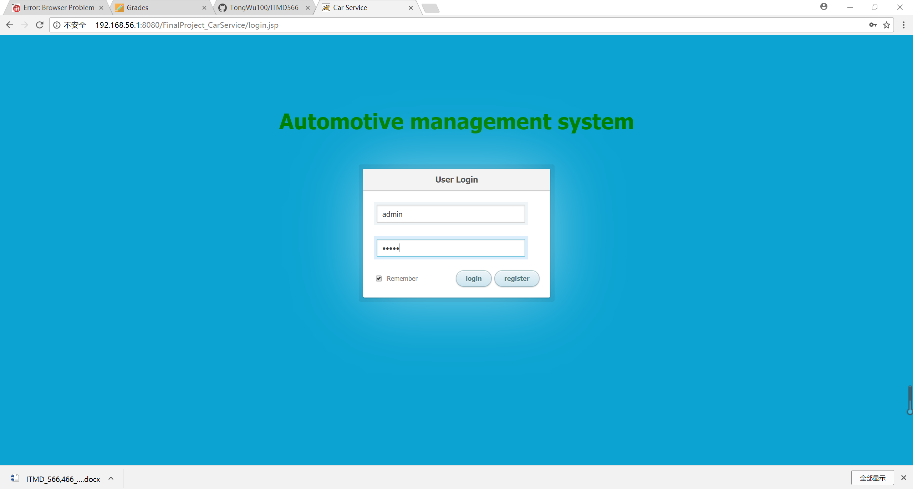

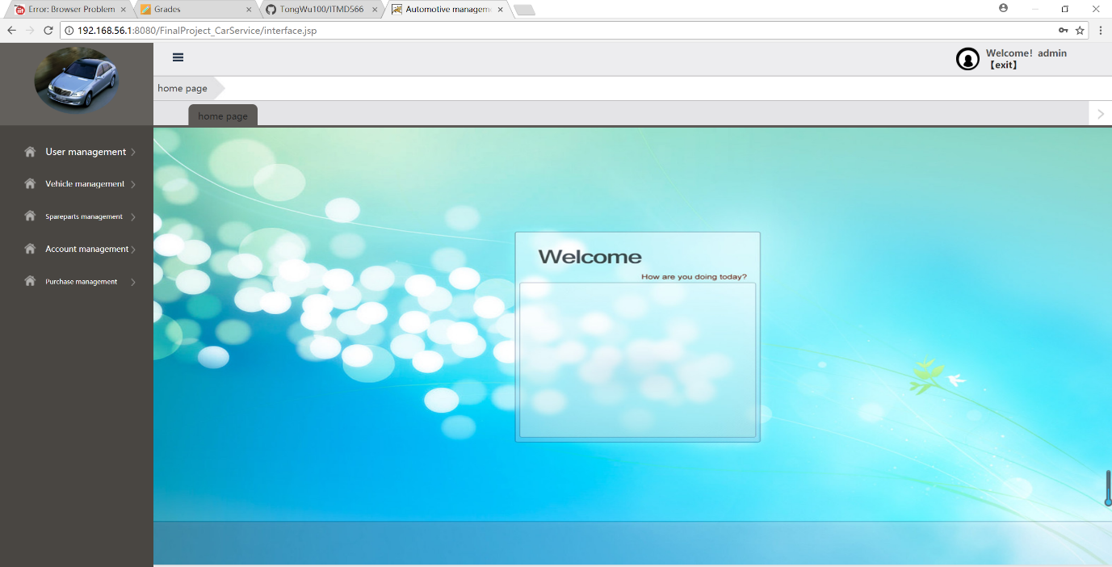

**Admin check customer information**

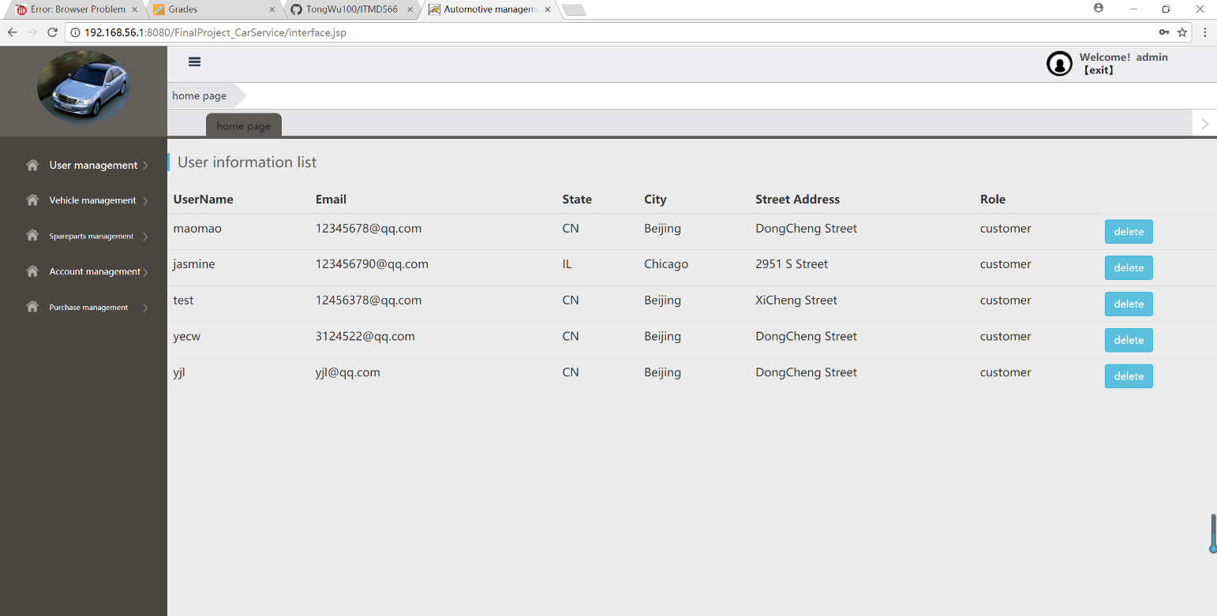

**Admin add new user**

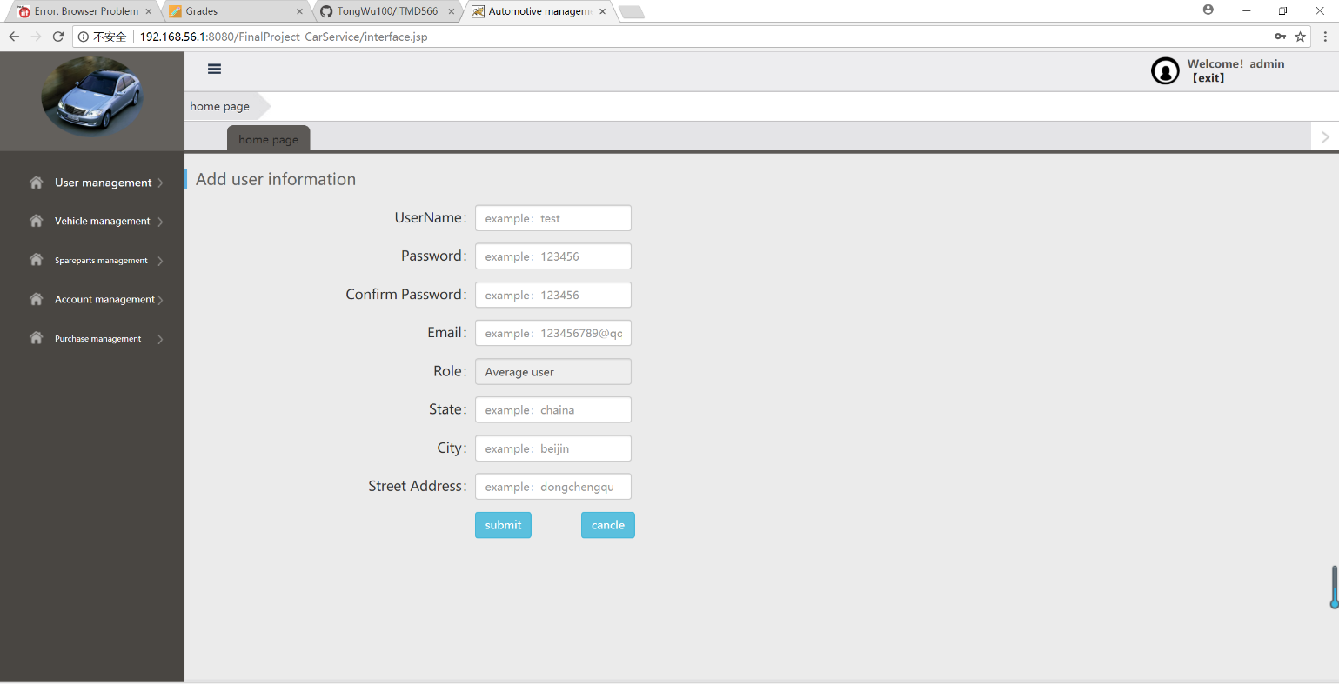

**Admin add new car**

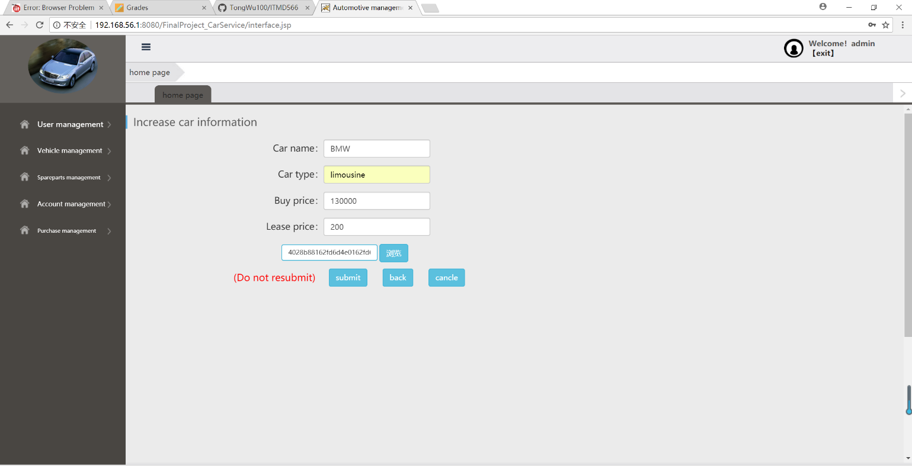

**Admin check car information**

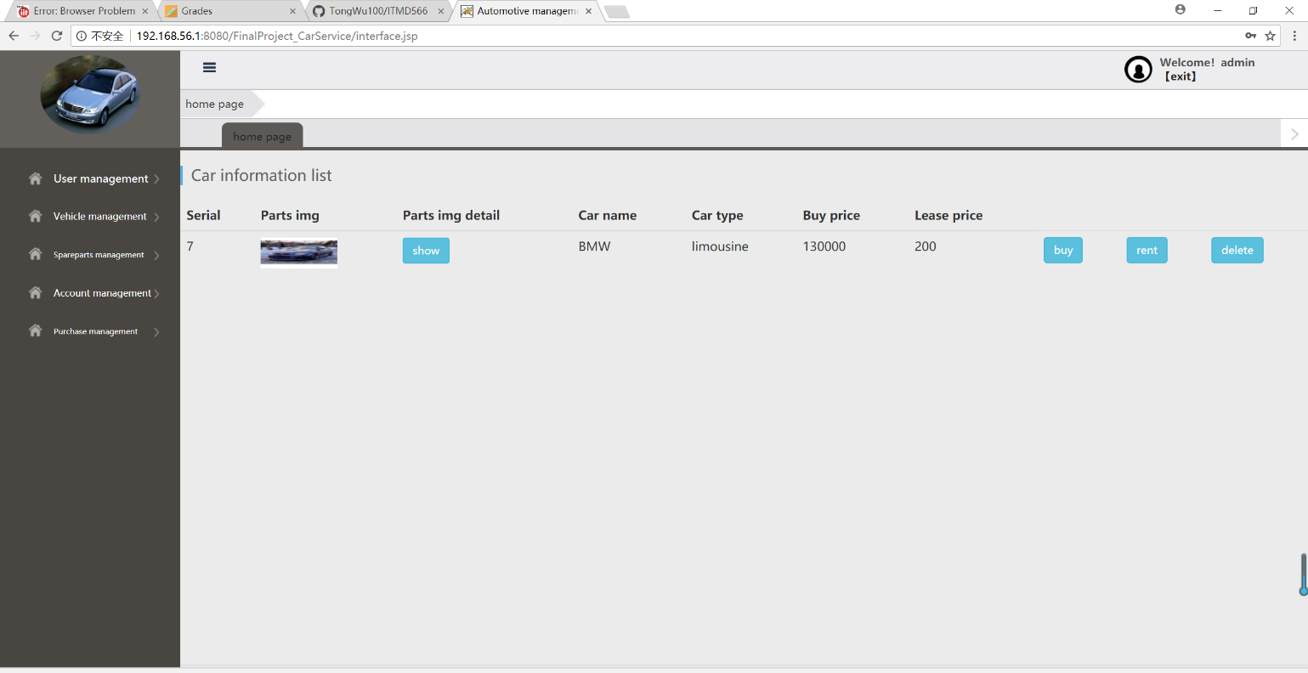

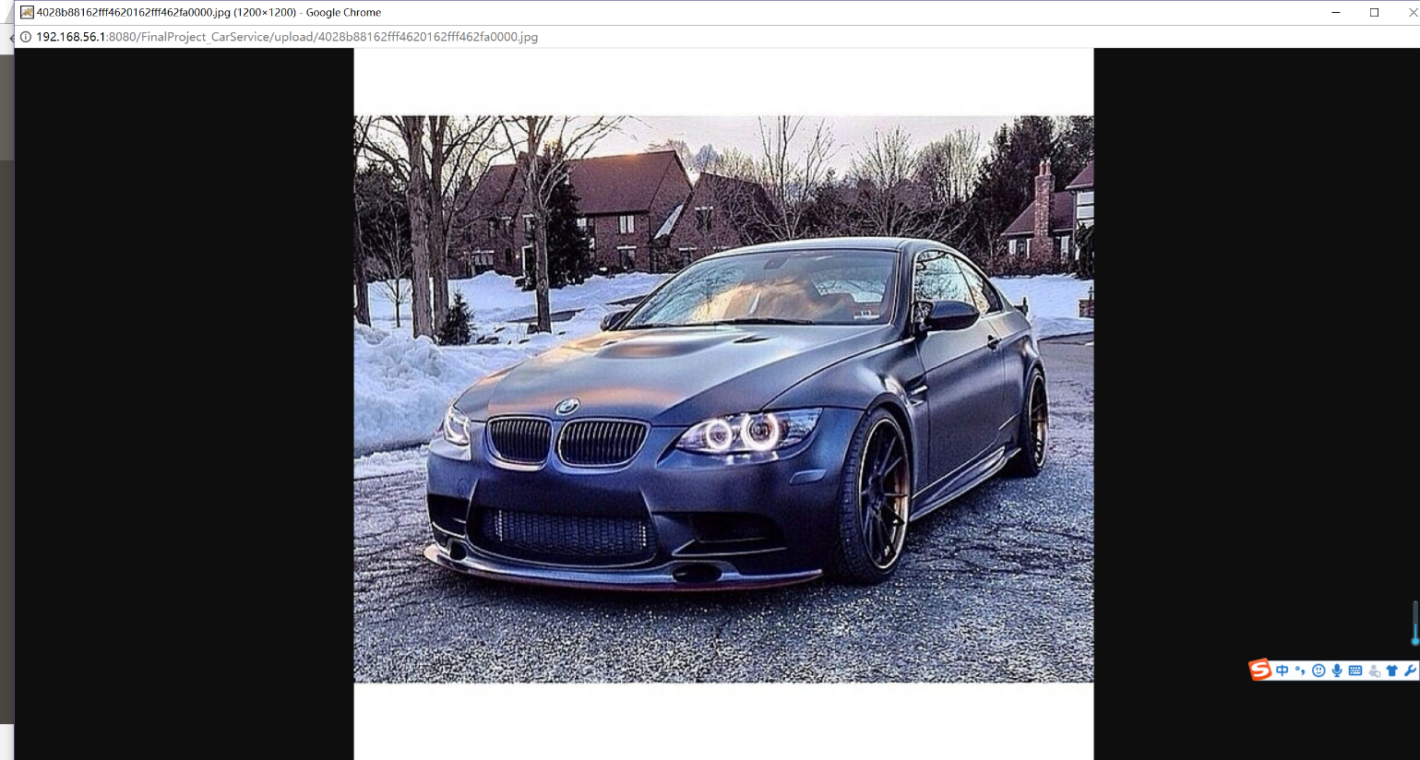

**Admin add new wheel**

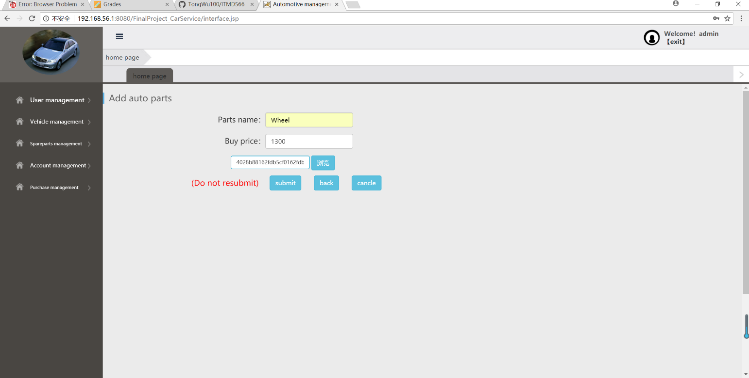

**Admin check new wheel**

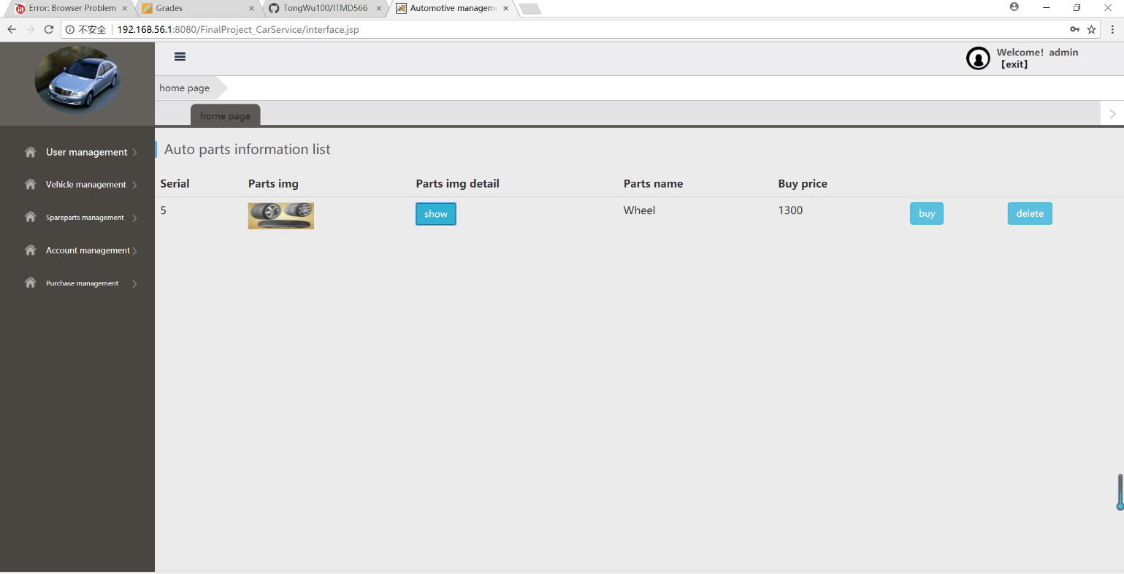

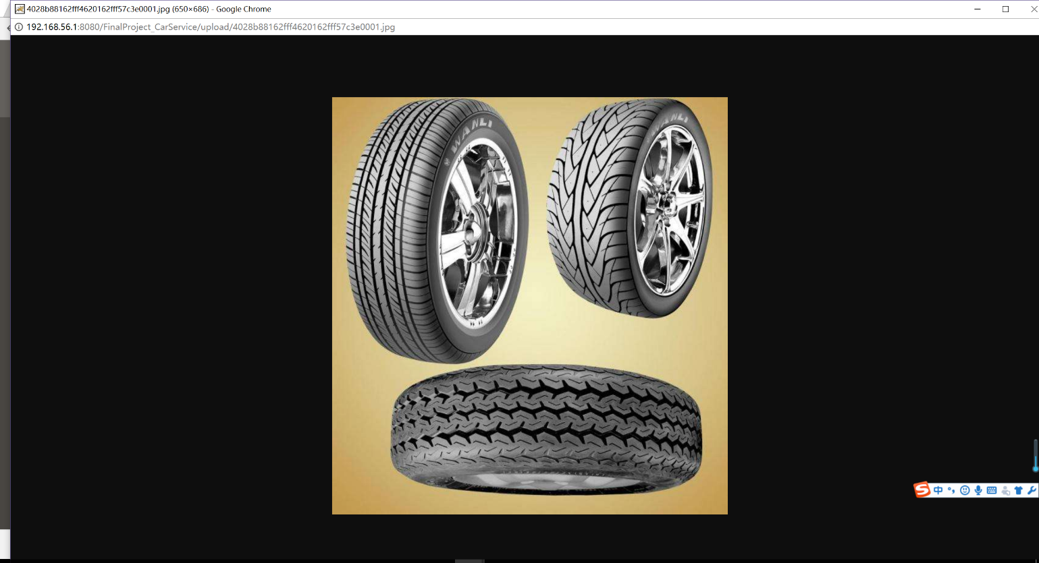

**Admin check transaction history**

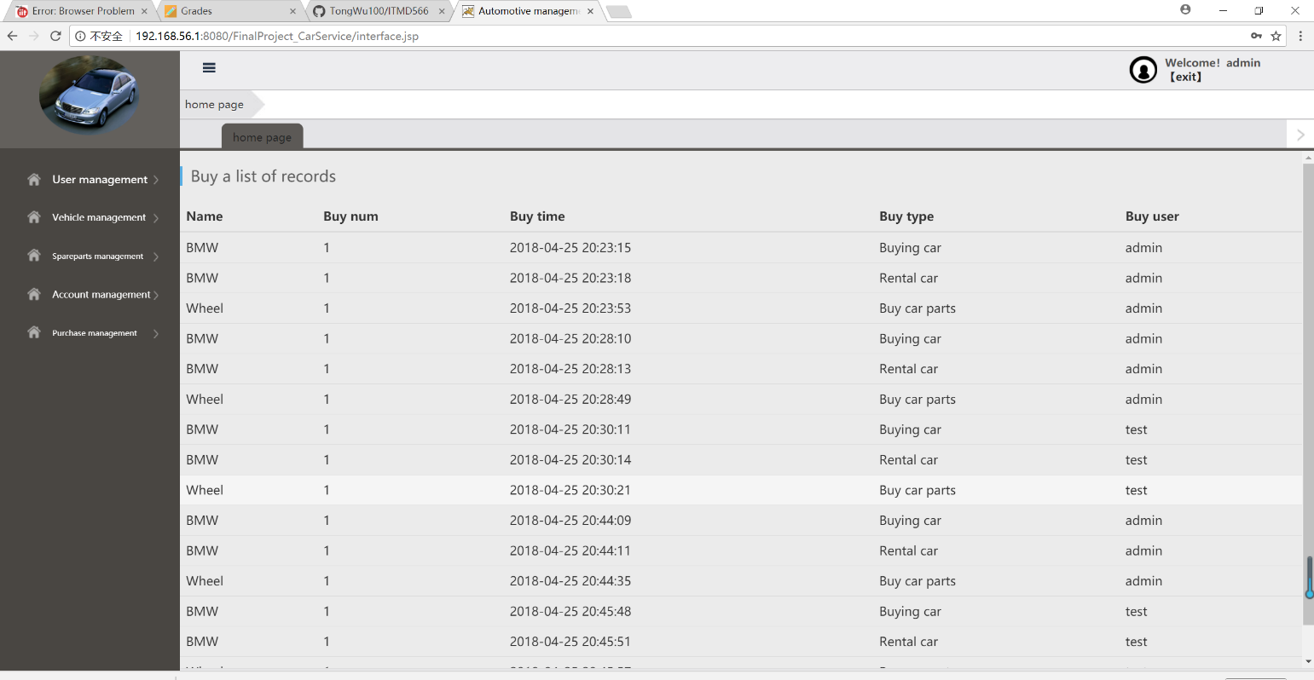

**Customer login**

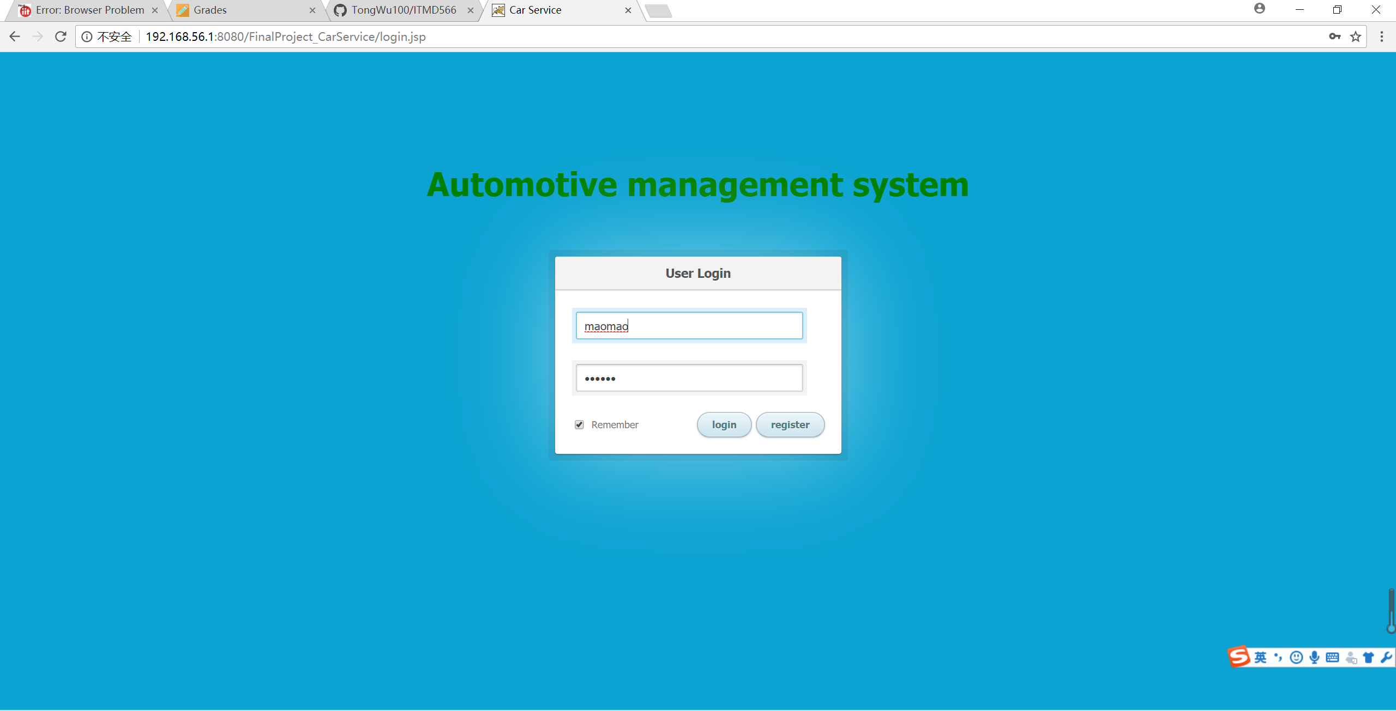

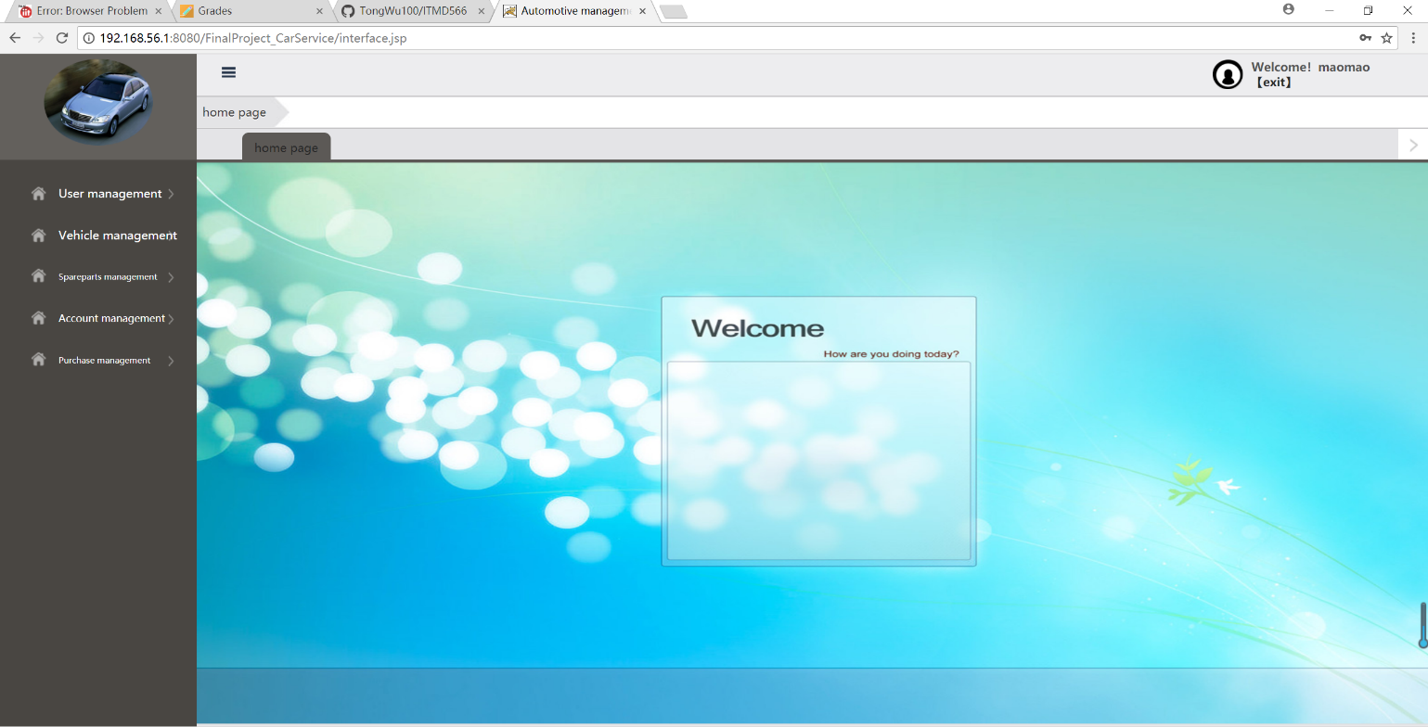

**Customer check own information**

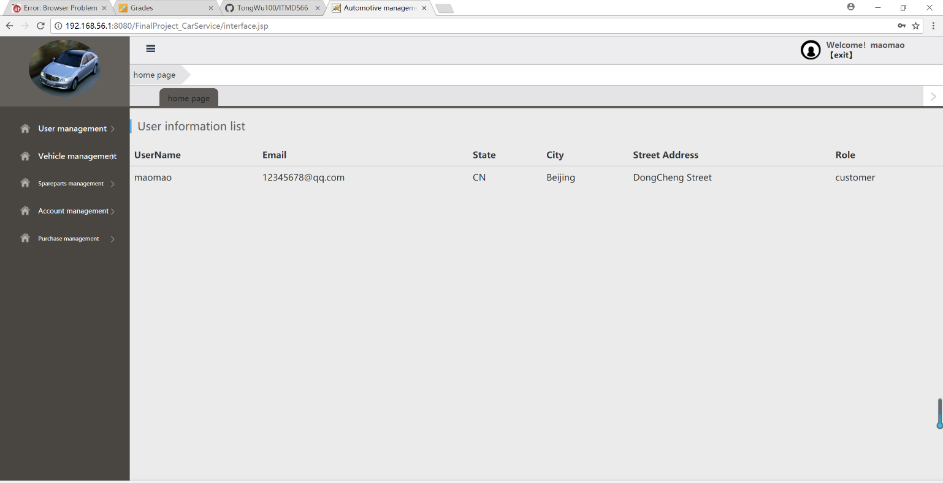

**Customer buy or rent a car**

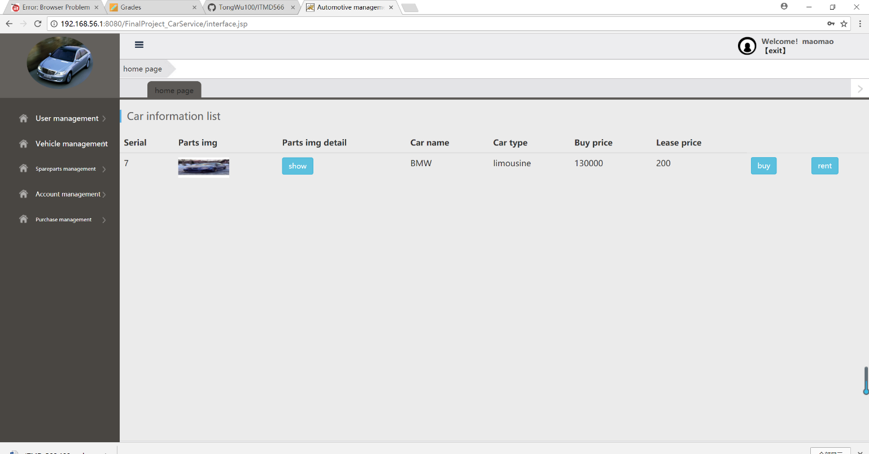

**Customer buy or rent a wheel**

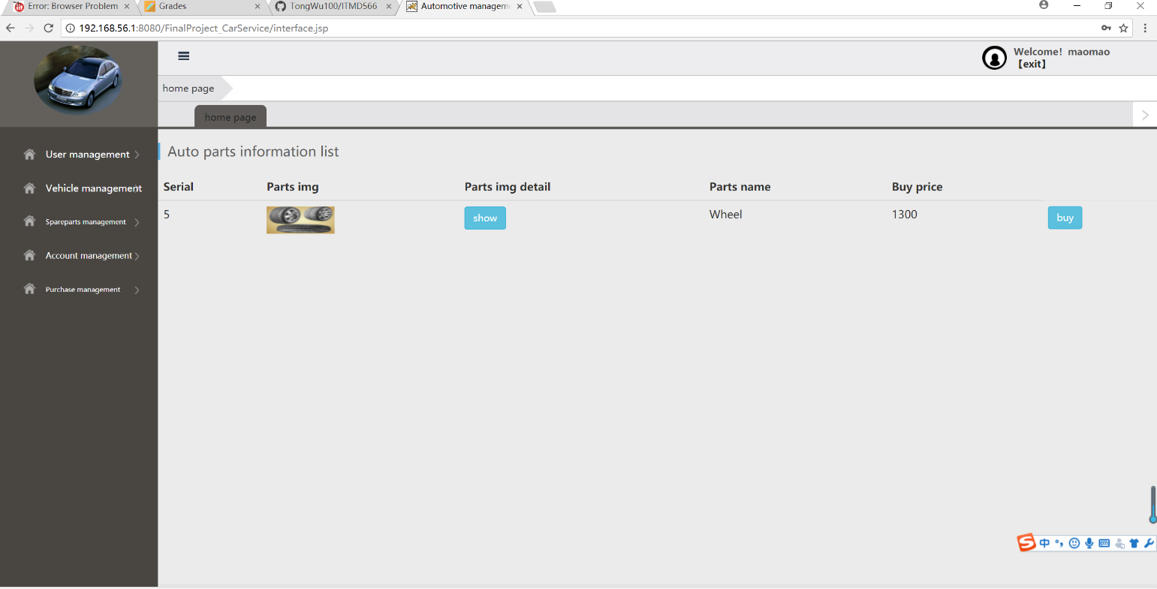

**Customer check transaction history**

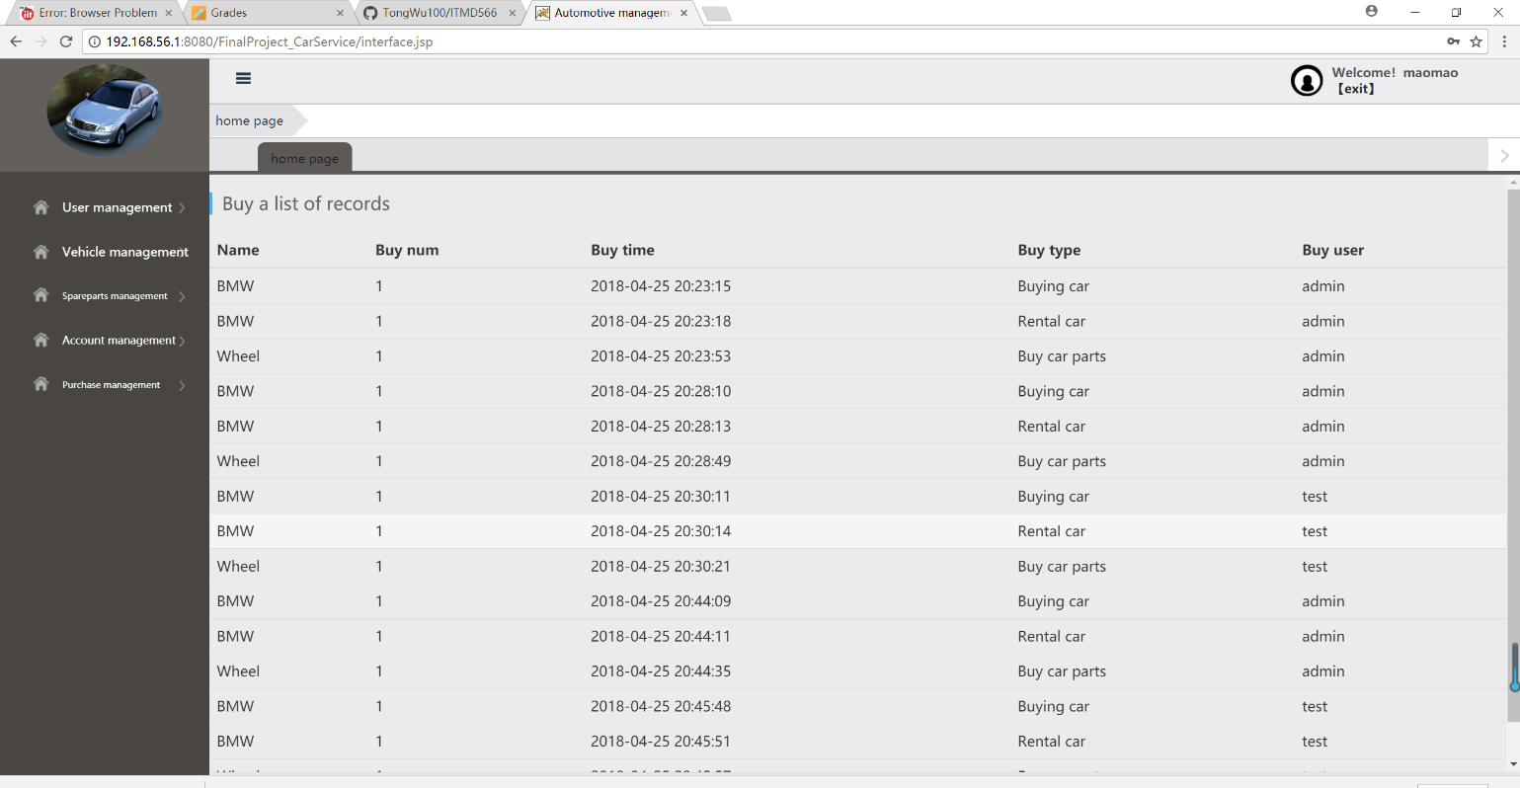

**User Registration**

